Final Project Report

AI-POWERED SMART HEALTH ASSISTANT



Project Supervisor
Shakeel Saeed

Submitted By

F25PROJECT664B0

Kainat Nadeem BC220422631

Software Projects & Research Section,
Department of Computer Sciences,
Virtual University of Pakistan


CERTIFICATE

This is to certify that Kainat Nadeem (BC220422631)have worked on and completed their Software Project at Software & Research Projects Section, Department of Computer Sciences, Virtual University of Pakistan in partial fulfillment of the requirement for the degree of BS in Computer Sciences under my guidance and supervision.

In our opinion, it is satisfactory and up to the mark and therefore fulfills the requirements of BS in Computer Sciences.

Supervisor / Internal Examiner

Shakeel Saeed
Supervisor,
Software Projects & Research Section,
Department of Computer Sciences
Virtual University of Pakistan

___________________
(Signature)

External Examiner/Subject Specialist
<<External Supervisor Name>>

___________________
(Signature)

Accepted By:

_____________
(For office use)

EXORDIUM

In the name of Allah, the Compassionate, the Merciful.

Praise be to Allah, Lord of Creation,
The Compassionate, the Merciful,
King of Judgment-day!

You alone we worship, and to You alone we pray for help,
Guide us to the straight path

The path of those who You have favored,

Not of those who have incurred Your wrath,
Nor of those who have gone astray.

DEDICATION



This work is dedicated to my parents, whose constant prayers, quiet sacrifices, and unwavering belief in me made this journey possible.

It is also dedicated to my supervisor, Mr. Shakeel Saeed, for his guidance, patience, and support throughout the development of this project.

Finally, to everyone who believes that technology, when built with empathy and responsibility, has the power to truly make a difference in people’s lives.
ACKNOWLEDGEMENT

All praise is due to Allah Almighty, whose blessings, guidance, and mercy made the completion of this project possible. His support gave me strength during challenges and clarity during moments of uncertainty.

I would like to express my sincere gratitude to my supervisor, Mr. Shakeel Saeed, for his continuous guidance, valuable feedback, and encouragement throughout this project. His insights played a key role in shaping both the technical and conceptual direction of this work.
I am also thankful to the Virtual University of Pakistan and the Department of Computer Sciences for providing a structured academic environment and the resources necessary to complete this Final Year Project.

Lastly, I am deeply grateful to my family for their constant support, patience, and encouragement. Their belief in me has been my strongest motivation throughout this journey.
PREFACE

This report presents the complete development journey of the AI-Powered Smart Health Assistant, covering all major phases from requirements analysis and system design to implementation and evaluation.

The project was carried out as part of the CS619 Final Year Project at the Virtual University of Pakistan. It is built around a real-world challenge: many individuals struggle to interpret their symptoms and often remain uncertain about when to seek medical attention. This system aims to bridge that gap by providing accessible, AI-driven preliminary health guidance.

By integrating machine learning and natural language processing techniques, the system analyzes user-described symptoms and generates meaningful insights, including possible conditions and recommended next steps. To ensure inclusivity, the platform supports both English and Urdu, making it accessible to a wider audience.

This report is organized into three main chapters in accordance with the VU Final Report structure.
Chapter 1 focuses on requirements gathering and analysis, including functional and non-functional requirements, use cases, and the adopted development methodology.
Chapter 2 presents the detailed system design, including architecture diagrams, sequence diagrams, class diagram, database design, and user interface design.
Chapter 3 describes the implementation phase, highlighting the technology stack, system modules, testing approach, and challenges encountered during development.
During the development phase, the explainability and bilingual processing modules were refined to use SHAP LinearExplainer and TF-IDF vectorization to achieve higher accuracy and transparency than initially planned in the SRS.

All content presented in this report has been carefully aligned with the previously submitted Software Requirements Specification (SRS) and Design Document to ensure consistency and continuity throughout the project lifecycle.

TABLE OF CONTENTS

CHAPTER NO. 1
gathering & Analyzing info 09

1.1 Introduction 10

1.2 scope 10

1.3 Functional AND NON-FUNCTIONAL REQUIREMENTS 13

1.4 definitions, acronyms and abbreviations 17

1.5 Use Case Diagrams 18

1.6 usage scenarios 19

1.7 Development Methodology 45
1.7 Chosen Methodology 45

1.7.2 Reasons for Chosen Methodology 48
1.7.2 Work Plan (Gantt Chart) 50
1.7.2 Project Schedule (Submission Calendar) 50

CHAPTER NO. 2
designing the project 52

2.1 Introduction 53

2.2 Entity RELATIONSHIP DIAGR AM 54

2.3 Dynamic Model: Sequence Diagrams 54

2.4 Architectural Representation (Architecture Diagram) 56

2.5 CLASS DIAGRAM 57

2.6 DATABASE DIAGRAM 58

2.7 Interface designs 59

2.8 test cases 64

Chapter no.3
DEvelopment 71
3.1 Development plan And Technology Stack 72

3.2 Module-Level Implementation 73

3.3 API Endpoints Reference 77

3.4 Test Cases & Results 78

3.5 Challenges & Solutions 81

3.6 Future Enhancements 82

CHAPTER 1
Gathering & Analyzing Info

1.1 Introduction
The AI-Powered Smart Health Assistant is an intelligent web-based platform that helps users understand their symptoms and receive preliminary health guidance before visiting a doctor. It was built as a Final Year Project under the CS619 course at the Virtual University of Pakistan, supervised by Shakeel Saeed.

The system accepts symptom descriptions through text or optional voice input, runs them through a machine learning classification pipeline, and returns the top three probable conditions along with confidence scores, triage recommendations, and a specialist suggestion. The output is explained using Explainable AI techniques so the user understands why those results were produced. The system supports both English and Urdu to make it accessible to a wider user base.

The motivation behind this project came from observing two common problems in everyday health situations. Some people panic about minor symptoms and rush to emergency rooms unnecessarily, while others ignore serious warning signs until the condition becomes critical. This assistant aims to provide calm, balanced, and evidence-based guidance that helps people make the right decision at the right time.

1.2 Scope of Project:

The AI-Powered Smart Health Assistant is an intelligent web-based platform that provides users with preliminary health guidance powered by artificial intelligence. The system analyzes user-described symptoms , through text or optional voice input , and predicts possible health conditions using machine learning and natural language processing (NLP) models.
The primary goal is to help users understand their potential health situation before consulting a doctor. By offering symptom-based insights, possible causes, and triage advice (whether to self-care, see a GP, or seek urgent care), the system bridges the gap between uncertainty and timely medical action.
The system also aims to address two common patterns observed among patients: those who become overly anxious about minor symptoms and those who ignore potentially serious ones. By providing balanced, evidence-based responses, the assistant helps users avoid unnecessary panic while ensuring timely medical attention when required. This approach brings emotional reassurance alongside accurate triage advice — making the experience both empathetic and responsible.
To make the system inclusive and user-friendly, it supports both English and Urdu languages, includes voice-based input, and offers a responsive, accessible interface across devices. It also ensures data security through encryption, providing registered users the ability to log in, review their previous queries, and manage their health history.
An admin dashboard allows authorized personnel to manage the system’s data, monitor usage patterns, and update medical information periodically. The system design draws inspiration from modern AI-based health assistants but improves upon them by focusing on accessibility, transparency, and natural interaction — eliminating robotic tones and limited access barriers found in many existing tools.
Furthermore, the system incorporates Explainable AI (XAI) techniques such as SHAP or LIME, providing users with clear reasoning behind predictions. This transparency enhances trust and makes the system educational, allowing users to understand why a certain condition or recommendation was made.
While the AI-Powered Smart Health Assistant offers advanced and interactive capabilities, it is not a replacement for healthcare professionals. Instead, it acts as an informational and educational tool that empowers users to make informed decisions and seek proper medical consultation when necessary.

Range of the Project
This project covers the design, development, and demonstration of a web-based application with the following key modules and deliverables:
1. Symptom Input & Processing
- Accepts free-text symptom descriptions (5–500 characters) or short voice clips (≤20 seconds).
- Performs text preprocessing (tokenization, normalization, entity extraction) using NLP techniques.
2. Prediction Engine
- Trains and deploys ML/NLP models to produce a ranked list of top 3 possible conditions with corresponding confidence scores.
- Utilizes medical symptom databases and contextual embeddings for higher accuracy.
3. Triage & Recommendation
- Provides next-step advice such as self-care, visiting a GP, or seeking urgent care.
- Recommends an appropriate specialist type (e.g., gynecologist, dermatologist, etc.) based on model output.
4. Explainability Module
- Uses SHAP/LIME visualization to explain the reasoning behind predictions by highlighting key symptomatic phrases and input features.
- Displays confidence percentages and influencing symptoms in clear terms.
5. User Management
- Supports both guest and registered user modes.
- Registered users can view health history, saved queries, and export reports (PDF format).
6. Multilingual UI & Accessibility
- Provides full English and Urdu interfaces with right-to-left (RTL) support for Urdu.
- Offers voice input for accessibility and ensures responsive design across devices.
7. Admin Tools (Stretch Goal)
- Allows authorized staff to manage knowledge base, update medical content, and track system analytics.
8. Privacy & Security Practices
- Implements data encryption, role-based access control (RBAC), and consent-based data storage.
- Filters personally identifiable information (PII) before storage.
9. Monitoring & Performance Targets
- Ensures system responsiveness within ~2.5 seconds for standard text queries.
- Demonstrates stability and basic monitoring for testing and demo purposes.
Out of Scope
The following items are excluded from this project’s scope:
- Official clinical diagnostics, prescription generation, or treatment planning.
- Integration with hospital EHR systems or direct clinical workflows.
- Full-scale production deployment (e.g., high-availability servers or SLAs).
- Long-term audio storage without user consent (only transcriptions will be retained).
- Real-time clinic booking integration (only prototype-level suggestions may be provided).
Limitations
Despite its wide functional range, the system has certain limitations:
- It does not provide official medical diagnoses or prescriptions.
- Prediction accuracy depends on the quality and diversity of training data.
- Voice recognition performance may vary based on noise and user accent.
- A stable internet connection is required for full functionality.
Sensitive data will not be stored or processed without explicit user consent.

1.3 Functional and non Functional Requirements:

→Functional Requirements
The AI-Powered Smart Health Assistant is designed to provide accessible, intelligent, and user-friendly health guidance. It performs a series of well-defined functions that ensure a smooth, secure, and informative experience for every user. The main functional requirements are as follows:
- Symptom-Based Guidance
The system should offer preliminary health guidance when a person is concerned about their health by analyzing the symptoms they describe.
- AI-Driven Interaction
The assistant should be powered by artificial intelligence to understand user inputs through text and, optionally, through voice commands.
- Symptom-to-Condition Translation
The system must translate user-provided symptoms into possible medical conditions using machine learning and natural language processing models.
- Severity and Condition Prediction
The assistant should display the predicted condition along with its estimated severity or criticality level.
- Accuracy Target
The system should aim to achieve at least 80% top-three accuracy in predicting relevant conditions based on the input data.
- Triage Recommendation
The system should guide users toward appropriate next steps such as self-care, visiting a general physician, or seeking urgent medical attention.
- Specialist Suggestion
Based on the analysis, the system should recommend a suitable specialist (e.g., dermatologist, gynecologist, pediatrician) relevant to the user’s symptoms.
- Fast Response Time
The system should respond quickly, with an average processing time of approximately 2.5 seconds per query.
- Multilingual Accessibility
The interface should be fully available in both English and Urdu, ensuring that users from different backgrounds can easily understand and interact with the assistant.
- Safety Disclaimer
A visible safety note or disclaimer should appear on every screen, reminding users that the assistant provides guidance only and is not a substitute for professional diagnosis.
- User Roles and Profiles
The system should support two primary user categories — Guest and Registered User.
  - Guests can enter symptoms and view basic results.
  - Registered users can create profiles, access their history, and receive more personalized guidance without re-entering full details each time.
- Admin / Clinician Reviewer (Optional)
An admin or clinician reviewer should be able to manage the knowledge base, approve updates, and oversee system analytics to maintain accuracy and safety.
- Explainability Panel
The assistant should display a clear explanation (using SHAP or LIME) showing which symptoms influenced the AI’s prediction, along with a brief, user-friendly rationale.
- Feedback Mechanism
Users should be able to rate the system’s response on a 1–5 scale and provide optional written feedback to help improve future versions of the assistant.
- Data Privacy and Consent Management
Before storing any information, the system should request user consent. All stored data should be anonymized and encrypted to ensure user privacy.
- Error Handling and Validation
The system should detect and handle incomplete, unclear, or unsafe inputs — for example, prompting the user for missing details or showing emergency contacts if self-harm is mentioned.
- Behavioral Sensitivity and Balanced Guidance
The system should be designed to handle two common types of user behavior:
- Over-concerned users who may misinterpret mild symptoms as severe conditions (e.g., assuming a simple flu is COVID-19).
- Under-concerned users who tend to ignore potentially serious symptoms (e.g., prolonged bleeding during menstruation).

→Non-Functional Requirements
The non-functional requirements define how the AI-Powered Smart Health Assistant will perform rather than what it will do. These requirements ensure that the system remains secure, reliable, user-friendly, and accessible to a wide audience.
1. Performance Requirements
- The system should respond to user queries within approximately 2.5 seconds under normal network conditions.
- It should handle multiple concurrent requests without noticeable delays or crashes.
- The AI model should maintain a prediction accuracy of at least 80% during symptom analysis.
2. Usability and Interface Requirements
- The interface will be designed with a clean, medical-themed color palette (primarily blue and white) to convey calmness and trust.
- The font style and layout will remain minimal and readable, reflecting the professional nature of healthcare platforms.
- The main page should include an interactive chatbot window that is clearly visible so users can easily start a conversation without searching for it.
- The system will support English and Urdu languages to ensure inclusivity and accessibility for a diverse user base.
- Icons, buttons, and prompts should follow a consistent design language and be accessible on all screen sizes (desktop, tablet, and mobile).
3. Reliability Requirements
- The system should provide consistent results during repeated queries.
- In case of any model or connection failure, a fallback message should guide the user politely to retry or contact support.
- Regular model updates and dataset improvements will ensure stable prediction quality.
4. Security and Privacy Requirements
- All user data and health queries must be stored securely using encryption at rest and in transit.
- The system should comply with data protection and user consent policies, clearly stating how data is used.
- Only authorized administrators will have access to the system database or model updates.
- No personal health data will be shared with third parties without explicit user permission.
5. Maintainability and Scalability
- The system should be easy to update, with modular components allowing smooth integration of new medical information or improved AI models.
- It should be capable of handling increased traffic and new features in the future without major architectural changes.
- An admin dashboard will support regular monitoring, updates, and log reviews.
6. Ethical and Legal Compliance
- The assistant must clearly display a safety disclaimer on every page, reminding users that it does not provide medical diagnoses or prescriptions.
- Recommendations will be evidence-based and designed to reduce panic or misinformation.
- The system will ensure that users are directed toward professional healthcare advice when needed, maintaining both ethical and responsible use of AI in healthcare.
7. Availability Requirements
- The web application will remain available at least 95% of the time during normal operation.
- A stable internet connection is required for full functionality, including AI response generation and data retrieval.

1.4 Definitions, Acronyms & Abbreviations

Term / Acronym | Definition
AI | Artificial Intelligence, the simulation of human intelligence by machines to perform tasks such as reasoning, learning, and decision-making
NLP | Natural Language Processing, a field of AI focused on understanding and processing human language
ML | Machine Learning, a technique that enables systems to learn patterns from data and improve predictions
SHAP | SHapley Additive exPlanations, a technique used to explain how machine learning models make predictions
LIME | Local Interpretable Model-Agnostic Explanations, an explainability method used to understand AI model outputs
XAI | Explainable Artificial Intelligence, AI systems designed to provide understandable and transparent decisions
HITL | Human-in-the-Loop, an approach where human involvement is included in the AI decision-making process
Triage | The process of categorizing patients or medical conditions based on the urgency of required care
UC | Use Case, a specific interaction between a user and the system
FR | Functional Requirement, a feature or function the system is expected to perform
NFR | Non-Functional Requirement, a requirement that defines how the system should perform
API | Application Programming Interface, a mechanism that allows communication between software components
REST | Representational State Transfer, a standard approach used for designing web-based APIs
RBAC | Role-Based Access Control, a security mechanism that restricts access according to user roles
PII | Personally Identifiable Information, data that can be used to identify an individual
SQLite | A lightweight and file-based relational database system used for data storage
FastAPI | A modern Python framework used for building fast and efficient REST APIs
React | A JavaScript library used for developing interactive user interfaces
RTL | Right-to-Left, a text direction used in languages such as Urdu and Arabic
PDF | Portable Document Format, a file format used for generating downloadable reports
SHA-256 | Secure Hash Algorithm 256-bit, a cryptographic method used for password hashing
WAL | Write-Ahead Logging, a SQLite mode that improves database performance and concurrent access
GP | General Physician, a doctor who provides primary healthcare services
ERD | Entity Relationship Diagram, a diagram that represents database entities and their relationships

1.5 Use Case Diagram(s):

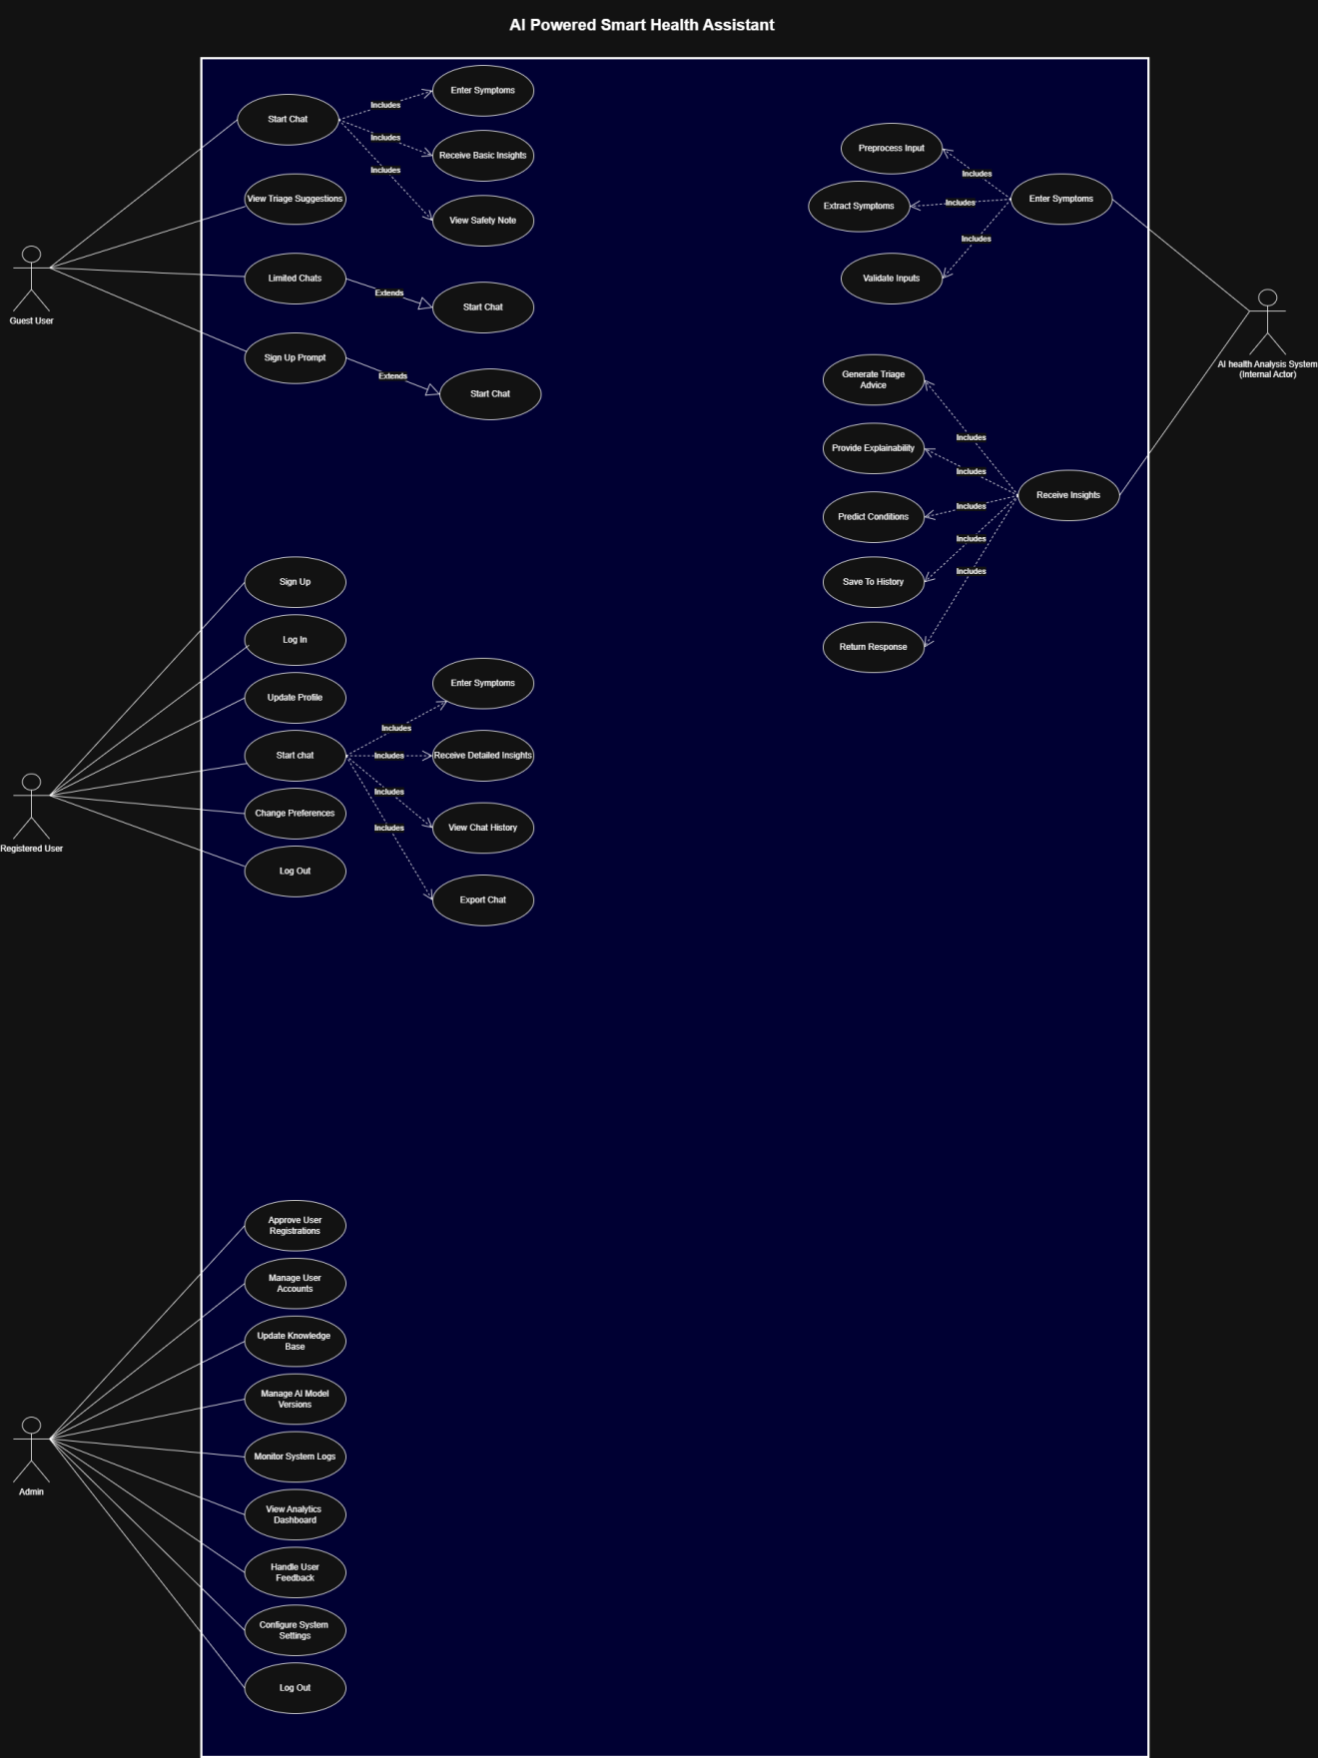

1.6 Usage Scenarios:

→Usage Scenario # 01:

Start Chat
Field | Details
Use Case Title | Start Chat
Use Case ID | UC-01
Description | This use case allows a guest user to initiate a conversation with the AI-powered Smart Health Assistant for the first time. The system provides a simple chat interface without requiring registration.
Primary Actor | Guest User
Pre-Conditions | - User must have access to the system (website or mobile app).- System must be online and functional.
Post-Conditions | - A chat session is created.- System logs guest interaction for analytics.
Actions / Main Flow | 1. Guest user opens the application.2. User selects “Start Chat as Guest.”3. System loads chat interface.4. AI Assistant sends a welcome message.5. Guest user begins the chat.6. System tracks chat count against the allowed limit.7. If limit approaches, system prepares a sign-up prompt (<>).
Alternative Paths | AP-01: If system fails to load chat interface, it displays a retry message.AP-02: If user is already logged in, system redirects to authenticated chat instead.
Exceptions | - System server is down → Show “Service unavailable.”- Internet connection issue → Ask user to check network.
Author | Kainat Nadeem

→Usage Scenario # 02:

Field | Details
Use Case Title | Limited Chats
Use Case ID | UC-02
Description | This use case manages the restriction applied to guest users, allowing them to send only a limited number of messages before requiring registration to continue chatting.
Primary Actor | Guest User
Pre-Conditions | - Guest user must have started a chat session (UC-01).- System must be tracking chat count.
Post-Conditions | - System may block further messages once the limit is reached.- Sign-up prompt is triggered (UC-03).
Actions / Main Flow | 1. Guest user sends messages in chat.2. System increases the message counter after each message.3. System compares the count with the allowed limit (e.g., 5 messages).4. When remaining messages are low, system prepares a soft reminder.5. When the limit reaches zero, system prevents sending new messages and triggers Sign-Up Prompt (extends).
Alternative Paths | AP-01: If guest user decides to sign up early, system stops tracking limit and upgrades the session.AP-02: If the user reloads the page, system retrieves the counter from session storage.
Exceptions | - System fails to track message count → user may receive unlimited access unintentionally.- Session corruption → counter resets to zero.
Author | Kainat Nadeem

→Usage Scenario # 03:

Field | Details
Use Case Title | Sign-Up Prompt
Use Case ID | UC-03
Description | The system displays a sign-up prompt to the guest user when the message limit is reached or when the user tries to access features reserved for registered users.
Primary Actor | Guest User
Pre-Conditions | - Guest user has either: • Reached message limit , • Tried accessing a restricted feature (e.g., save chat, view history).
Post-Conditions | - System shows a sign-up dialog or redirect option.- User may choose to sign up or close the prompt.
Actions / Main Flow | 1. System detects message limit exceeded OR access to restricted feature.2. System blocks further actions temporarily.3. System displays the sign-up prompt (popup/modular window).4. User views available account benefits (e.g., unlimited chats, save history).5. User chooses one of the options: Sign Up or Close Prompt.
Alternative Paths | AP-01: User closes the prompt → System returns to previous screen but still restricts further messaging.AP-02: User clicks "Remind me later" → System hides the prompt, but limit remains enforced.
Exceptions | - Popup fails to load due to slow internet → fallback inline message shown.- User presses back button → system reloads chat with the same restriction.
Author | Kainat Nadeem

→Usage Scenario # 04:

Field | Details
Use Case Title | Enter Symptoms
Use Case ID | UC-04
Description | Guest user enters their symptoms into the chat input field to start receiving AI-generated insights.
Primary Actor | Guest User
Pre-Conditions | - Guest has started a chat (UC-01).- Chat input is available and active.
Post-Conditions | - Symptoms are sent to the system for processing.- System triggers “Receive Basic Insights” (UC-05).
Actions / Main Flow | 1. User types symptoms (e.g., “fever, headache”).2. System validates text format.3. User clicks Send.4. System forwards symptoms to AI Analysis actor.
Alternative Paths | AP-01: User enters irrelevant text → System shows “Please enter symptoms only.”AP-02: User leaves the input blank → System shows a gentle reminder.
Exceptions | - Internet issue → system shows retry message.- Input too long → system asks to shorten symptoms.
Author | Kainat Nadeem

→Usage Scenario # 05:

Field | Details
Use Case Title | Receive Basic Insights
Use Case ID | UC-05
Description | After symptoms are submitted, the system generates simple, non-medical insights based on user input.
Primary Actor | System (AI Health Analyzer)
Pre-Conditions | - Symptoms successfully submitted (UC-04).
Post-Conditions | - Basic insights displayed to user.- Safety Note (UC-06) is triggered afterward.
Actions / Main Flow | 1. System receives symptoms.2. AI processes input and selects general insights.3. System displays non-diagnostic suggestions (e.g., hydration, rest).4. System prepares to show Safety Note.
Alternative Paths | AP-01: System cannot interpret symptoms → generic guidance displayed.AP-02: System detects sensitive/emergency keywords → triggers urgent safety warning early.
Exceptions | - Model error → System displays fallback “Unable to process, try again.”
Author | Kainat Nadeem

→Usage Scenario # 06:

Field | Details
Use Case Title | View Safety Note
Use Case ID | UC-06
Description | The system shows a safety disclaimer ensuring the user understands that insights are informational, not medical advice.
Primary Actor | System
Pre-Conditions | - Basic insights have been generated (UC-05).
Post-Conditions | - User acknowledges the note (implicitly).- System returns to chat interface.
Actions / Main Flow | 1. System displays a brief safety message under the insights.2. User reads it.3. Chat continues normally.
Alternative Paths | AP-01: User clicks “Learn More” → system opens a longer disclaimer modal.AP-02: User ignores the note → no issue, chat continues.
Exceptions | - Safety note fails to load → fallback minimal warning appears.
Author | Kainat Nadeem

→Usage Scenario # 07:

Field | Details
Use Case Title | Sign Up
Use Case ID | UC-07
Actor | Registered User (New User)
Description | This use case describes how a new user creates an account by providing basic personal details so the system can personalize health guidance and save chat history for future use.
Actions (Main Flow) | 1. User opens the website and selects “Sign Up.”2. System displays a sign-up form (name, age, gender, email, password).3. User enters details and submits the form.4. System validates input fields.5. System sends a verification link to the user’s email.6. User clicks the email verification link.7. System activates the account and confirms successful sign-up.
Pre-Conditions | 1. User must have a valid email address.2. System must be connected to the email service to send verification links.
Post-Conditions | 1. User becomes a Registered User.2. User can now log in, access unlimited chats, and maintain chat history.
Alternative Paths | A1: Missing/invalid info → System displays an error and asks the user to correct it.A2: Email already registered → System notifies user and suggests logging in.A3: Verification link expired → User requests a new verification email.
Exceptions | E1: Email service is down → System shows “Verification temporarily unavailable.”E2: User enters a weak password → System prompts for a stronger one.
Author | Kainat Nadeem

→Usage Scenario # 08:

Field | Details
Use Case Title | Log In
Use Case ID | UC-08
Actor | Registered User
Description | This use case explains how a registered user securely logs into the system to access personalized features, saved chat history, and unlimited health assistant interactions.
Actions (Main Flow) | 1. User opens website and clicks “Log In.”2. System displays login form (email + password).3. User enters credentials.4. System validates email format and password length.5. System checks credentials in the database.6. If correct, the system logs the user in and redirects to dashboard/home page.
Pre-Conditions | 1. User must already have a registered and verified account.2. System must be connected to the authentication service.
Post-Conditions | 1. User is successfully authenticated.2. User can now start chat, view saved history, and use personalized features.
Alternative Paths | A1: Incorrect password → System shows error and allows retry.A2: Email not found → System suggests signing up instead.A3: User forgot password → User clicks “Forgot Password” to reset.
Exceptions | E1: Server error during login validation → System shows “Login unavailable, try again later.”E2: Multiple failed attempts → System temporarily locks the account for security.
Author | Kainat Nadeem

→Usage Scenario # 09:

Field | Details
Use Case Title | Update Profile
Use Case ID | UC-09
Actor | Registered User
Description | This use case allows a registered user to update their personal details such as name, age, gender, medical history, profile picture, or password to maintain an accurate and personalized health experience.
Actions (Main Flow) | 1. User opens profile settings.2. System displays editable fields.3. User updates desired information.4. User clicks Save Changes.5. System validates fields and updates the database.6. System confirms successful update.
Pre-Conditions | 1. User must be logged in.2. System must have access to user profile data.
Post-Conditions | 1. Profile information is updated in the database.2. System reflects changes immediately in user dashboard.
Alternative Paths | A1: User leaves a required field empty → System prompts to fill it.A2: User uploads an unsupported file as profile picture → System displays “Invalid file format.”
Exceptions | E1: Server not responding → System shows “Unable to save changes, try again later.”
Author | Kainat Nadeem

→Usage Scenario # 10:

Field | Details
Use Case Title | Start Chat (Registered User)
Use Case ID | UC-10
Actor | Registered User
Description | A registered user begins a new conversation with the AI health assistant, gaining access to unlimited chats and saved history.
Actions (Main Flow) | 1. User clicks Start Chat button.2. System opens chat interface.3. System greets user personally (“Welcome back, Kainat!”).4. Chat session becomes active.
Pre-Conditions | 1. User must be logged in.2. Chat module must be active.
Post-Conditions | 1. A new chat session is initialized.2. Conversation is automatically saved in user’s history.
Alternative Paths | A1: User tries to start chat during maintenance → System shows maintenance notice.A2: Internet disconnects mid-loading → System retries connection or shows offline error.
Exceptions | E1: Chatbot API fails → System displays “Assistant unavailable at the moment.”
Author | Kainat Nadeem

→Usage Scenario # 11:

Field | Details
Use Case Title | Enter Symptoms
Use Case ID | UC-11
Actor | Guest User / Registered User
Description | User enters one or more symptoms in the chatbox, allowing the AI health assistant to begin analyzing the user's condition.
Actions (Main Flow) | 1. Chatbot asks user to describe symptoms.2. User types symptoms (e.g., “fever and sore throat”).3. System performs spell-check and natural language processing.4. System stores symptoms temporarily for analysis.
Pre-Conditions | 1. A chat session must already be active.2. Chat input field must be functional.
Post-Conditions | 1. Symptoms are accepted and processed.2. System proceeds to generate basic insights.
Alternative Paths | A1: User enters unclear symptoms → System asks follow-up question (e.g., “How long have you had fever?”).A2: User sends empty input → System prompts “Please enter at least one symptom.”
Exceptions | E1: NLP engine fails → System shows “Unable to understand input, try again.”
Author | Kainat Nadeem

→Usage Scenario # 12:

Field | Details
Use Case Title | Receive Detailed Insights
Use Case ID | UC-12
Actor | Registered User
Description | After entering symptoms, the AI system provides a more detailed insight including possible conditions, severity level indicators, symptom explanations, and recommended next steps. This deeper insight is only available to registered users.
Actions (Main Flow) | 1. User enters symptoms.2. System analyzes symptom patterns using AI engine.3. System generates possible conditions with confidence levels.4. System displays detailed analysis with easy-to-understand wording.5. User can ask follow-up questions if needed.
Pre-Conditions | 1. User must be logged in.2. Symptoms must already be submitted.
Post-Conditions | 1. User receives personalized insights.2. Insights are saved to chat history.
Alternative Paths | A1: Symptoms conflict or are medically ambiguous → System asks clarifying questions.A2: User accidentally enters too many symptoms at once → System suggests adding details step-by-step.
Exceptions | E1: AI model fails to process → System shows “Unable to analyze symptoms, please try again.”
Author | Kainat Nadeem

→Usage Scenario # 13:

Field | Details
Use Case Title | View Chat History
Use Case ID | UC-13
Actor | Registered User
Description | This use case lets the user revisit previous conversations with the AI assistant to track symptoms, recommendations, and progress over time.
Actions (Main Flow) | 1. User clicks Chat History tab.2. System retrieves stored conversations.3. System displays chat list sorted by date and time.4. User selects a specific conversation.5. The full chat opens for review.
Pre-Conditions | 1. User must be logged in.2. User must have at least one saved chat.
Post-Conditions | 1. Chat history is displayed.2. User may export or continue chat from history.
Alternative Paths | A1: User has no saved chats → System shows “No chat history found.”A2: User’s internet is slow → System loads chats in batches.
Exceptions | E1: Database retrieval error → System shows “Unable to load history.”
Author | Kainat Nadeem

→Usage Scenario # 14:

Field | Details
Use Case Title | Export Chat
Use Case ID | UC-14
Actor | Registered User
Description | The user exports a selected chat session as a PDF or text file for personal records or to share with a doctor.
Actions (Main Flow) | 1. User opens a chat from history.2. User clicks Export Chat.3. System asks for file format (PDF/TXT).4. User selects format.5. System generates file.6. System prompts user to download.
Pre-Conditions | 1. User must be logged in.2. The selected chat must exist in history.
Post-Conditions | 1. Chat is successfully exported and downloaded.2. System logs export action.
Alternative Paths | A1: User cancels export → System returns to chat screen.A2: Unsupported format selected → System shows “Format not available.”
Exceptions | E1: File generation error → System shows “Chat export failed, please try again.”
Author | Kainat Nadeem

→Usage Scenario # 15:

Field | Details
Use Case Title | Change Preferences
Use Case ID | UC-15
Actor | Registered User
Description | The user modifies personal settings such as notification preferences, chatbot tone, language, or theme to personalize the system experience.
Actions (Main Flow) | 1. User opens Settings.2. System displays available preferences.3. User selects a preference to modify.4. User updates the preference.5. System saves changes.6. System confirms.
Pre-Conditions | 1. User must be logged in.2. Settings page must be accessible.
Post-Conditions | 1. Updated preferences are saved.2. New settings apply to future interactions.
Alternative Paths | A1: Invalid input → System highlights error and requests correction.A2: User cancels changes → System discards updates and returns to settings.
Exceptions | E1: System fails to save preferences → Displays “Unable to update settings. Please try again.”
Author | Kainat Nadeem

→Usage Scenario # 16:

Field | Details
Use Case Title | Log Out
Use Case ID | UC-16
Actor | Registered User
Description | The user securely ends their session and returns to the homepage or guest user interface.
Actions (Main Flow) | 1. User clicks Log Out.2. System asks for confirmation (optional).3. User confirms.4. System ends session.5. System redirects user to guest/landing page.
Pre-Conditions | 1. User must be logged in.
Post-Conditions | 1. User session is terminated.2. User becomes a guest user.
Alternative Paths | A1: User cancels logout → System returns to previous screen.A2: Auto logout due to inactivity → On next action, system shows “Your session has expired. Please log in again.”
Exceptions | E1: System cannot terminate session properly → Displays “Logout failed. Try again later.”
Author | Kainat Nadeem

→Usage Scenario # 17:

Field | Details
Use Case Title | Approve User Registrations
Use Case ID | UC-17
Actor | Admin
Description | The admin reviews pending user registration requests and approves or rejects them to ensure legitimate access to the system.
Actions (Main Flow) | 1. Admin logs into the system.2. Admin navigates to Pending Registrations section.3. System displays list of unapproved users.4. Admin selects a user.5. Admin clicks Approve.6. System updates user status to “Approved”.
Pre-Conditions | 1. Admin must be logged in.2. There must be pending registration requests.
Post-Conditions | 1. User account becomes active.2. User is notified of approval (email/system message).
Alternative Paths | A1: Admin clicks Reject instead of approve → System marks user as rejected.A2: Admin filters list (by date/name) before approving.
Exceptions | E1: Database error during approval → System displays “Approval failed. Please try again.”E2: User request already processed → System shows “This registration has already been handled.”
Author | Kainat Nadeem

→Usage Scenario # 18:

Field | Details
Use Case Title | Manage User Accounts
Use Case ID | UC-18
Actor | Admin
Description | Admin manages registered user accounts by suspending, restoring, or resetting passwords to maintain platform safety and smooth use.
Actions (Main Flow) | 1. Admin opens User Management Panel.2. Selects a user from the list.3. Clicks Suspend, Restore, or Reset Password.4. System updates the account status.5. System logs the action.
Pre-Conditions | 1. Admin must be authenticated.2. Target user must exist in system database.
Post-Conditions | 1. User account updated successfully.2. System logs administrative action for audit trail.
Alternative Paths | A1: Admin searches user using filters (email/name).A2: Admin cancels action → Returns to dashboard.
Exceptions | E1: Database connection error → “Action failed, please try again.”E2: User account already suspended → System shows warning.
Author | Kainat Nadeem

→Usage Scenario # 19:

Field | Details
Use Case Title | Update Knowledge Base
Use Case ID | UC-19
Actor | Admin
Description | Admin updates symptom synonyms, condition mappings, and general medical guidance to keep the system accurate and up-to-date.
Actions (Main Flow) | 1. Admin opens Knowledge Base Management.2. Selects an item to edit (symptom, condition, template).3. Makes updates.4. Clicks Save Changes.5. System validates and applies updates.6. System stores version for rollback.
Pre-Conditions | 1. Admin logged in.2. Knowledge base module must be functional.
Post-Conditions | 1. New content saved and versioned.2. Updated knowledge reflected in system outputs.
Alternative Paths | A1: Admin clicks Rollback → System restores previous version.A2: Admin previews update before saving.
Exceptions | E1: Validation fails (“Invalid content”).E2: Save error due to server issue.
Author | Kainat Nadeem

→Usage Scenario # 20:

Field | Details
Use Case Title | Manage AI Model Versions
Use Case ID | UC-20
Actor | Admin
Description | Admin deploys new ML model versions, monitors performance, and rolls back if model accuracy decreases.
Actions (Main Flow) | 1. Admin opens the Model Management panel.2. Uploads a new model file or selects existing update.3. Clicks Deploy Model.4. System validates model.5. System activates new version.6. Admin monitors performance metrics.
Pre-Conditions | 1. Admin authenticated.2. New model version available.3. System must support version switching.
Post-Conditions | 1. New model deployed.2. System logs model version and timestamp.
Alternative Paths | A1: Admin clicks Rollback → Previous model becomes active.A2: Admin tests model in “Preview/Test Mode” before deployment.
Exceptions | E1: Model fails validation → “Model incompatible.”E2: Deployment failure due to server issue.E3: Upload error (file corrupt).
Author | Kainat Nadeem

→Usage Scenario # 21:

Field | Details
Use Case Title | View Analytics Dashboard
Use Case ID | UC-21
Actor | Admin
Description | Admin views system-wide analytics including total users, active users, common symptoms, and average response time.
Actions (Main Flow) | 1. Admin opens Analytics Dashboard.2. System loads visual charts and metrics.3. Admin reviews insights.4. Admin applies filters (time range, region).
Pre-Conditions | Analytics module must be functional.
Post-Conditions | Admin gains insights for system improvement decisions.
Alternative Paths | A1: Admin downloads analytics report.A2: Changes graph types for deeper insights.
Exceptions | E1: Dashboard fails to load → System shows fallback message.E2: Chart rendering error.
Author | Kainat Nadeem

→Usage Scenario # 22:

Field | Details
Use Case Title | Handle User Feedback
Use Case ID | UC-22
Actor | Admin
Description | Admin reviews user feedback, resolves issues, and sends responses when required.
Actions (Main Flow) | 1. Admin opens Feedback Management.2. Reviews feedback list.3. Clicks on a feedback entry.4. Marks it as resolved or responds to user.5. System logs the action.
Pre-Conditions | Feedback must exist.
Post-Conditions | Feedback addressed and recorded as resolved.
Alternative Paths | A1: Admin filters feedback by category (technical, medical, UI).
Exceptions | E1: Response fails due to connectivity issue.E2: Feedback entry deleted by another admin simultaneously.
Author | Kainat Nadeem

→Usage Scenario # 23:

Field | Details
Use Case Title | Configure System Settings
Use Case ID | UC-23
Actor | Admin
Description | Admin updates system-wide settings like UI language toggle, voice input availability, maintenance mode, and usage limits.
Actions (Main Flow) | 1. Admin opens Settings Panel.2. Selects a configuration item.3. Updates value.4. Clicks Save Settings.5. System confirms update.
Pre-Conditions | Admin authenticated.
Post-Conditions | System updates configuration and applies changes instantly or after reload.
Alternative Paths | A1: Admin tests changes in “Preview Mode.”
Exceptions | E1: Invalid configuration → “Value out of range.”E2: Save failed due to server error.
Author | Kainat Nadeem

→Usage Scenario # 24:

Field | Details
Use Case Title | Logout
Use Case ID | UC-24
Actor | Admin
Description | Admin securely logs out of the system to end their session.
Actions (Main Flow) | 1. Admin clicks Logout.2. System clears session tokens.3. Admin returned to login page.
Pre-Conditions | Admin must be logged in.
Post-Conditions | Admin session ends successfully and securely.
Alternative Paths | A1: Admin closes browser instead of using logout button → System auto-expires session.
Exceptions | E1: Session timeout before logout → System forces re-login.
Author | Kainat Nadeem

→Usage Scenario # 25:

Field | Details
Use Case Title | Preprocess Input
Use Case ID | UC-25
Actor | AI Health Analysis System
Description | The AI system cleans and normalizes user-provided text/voice input before analysis.
Actions (Main Flow) | 1. System receives raw input (text or converted voice).2. Removes grammar noise, stop words, typos using NLP cleaning.3. Normalizes medical terms (e.g., “feaver” → “fever”).4. Detects metadata (age, severity if provided).5. Sends cleaned input to extraction module.
Pre-Conditions | User must submit symptoms via chat.
Post-Conditions | A clean, standardized input text is produced for further processing.
Alternative Paths | A1: If voice input is used → System performs Speech-to-Text first.
Exceptions | E1: Input is empty → System returns “Please enter your symptoms.”E2: Audio unintelligible → System asks user to repeat.

→Usage Scenario # 26:

Field | Details
Use Case Title | Extract Symptoms
Use Case ID | UC-26
Actor | AI Health Analysis System
Description | System identifies medical symptoms from user input using NLP entity extraction.
Actions (Main Flow) | 1. Receives cleaned input from preprocessing module.2. NLP model extracts symptoms, keywords, and severity indicators.3. Maps synonyms (e.g., “tummy pain” → “abdominal pain”).4. Tags extracted symptoms with metadata (duration, intensity).
Pre-Conditions | Preprocessed text must be available.
Post-Conditions | Structured list of symptoms is generated.
Alternative Paths | A1: If multiple symptoms detected → List is grouped.A2: If uncertain → System marks low-confidence symptoms.
Exceptions | E1: No symptoms detected → System prompts: “Try describing your symptoms in more detail.”
Author | Kainat Nadeem

→Usage Scenario # 27:

Field | Details
Use Case Title | Predict Conditions
Use Case ID | UC-27
Actor | AI Health Analysis System
Description | The AI model predicts the top possible health conditions based on extracted symptoms.
Actions (Main Flow) | 1. AI model receives structured symptoms.2. Converts them into feature vectors.3. Runs ML/DL classifier.4. Generates top-k likely conditions with confidence scores.5. Sends results to triage module.
Pre-Conditions | Symptoms must be extracted successfully.
Post-Conditions | Condition predictions with confidence values are produced.
Alternative Paths | A1: If low confidence across predictions → System shows “Uncertain result — consider consulting a doctor.”
Exceptions | E1: Model failure → System uses fallback lightweight model.
Author | Kainat Nadeem

→Usage Scenario # 28:

Field | Details
Use Case Title | Generate Triage Advice
Use Case ID | UC-28
Actor | AI Health Analysis System
Description | System produces personalized next-step medical guidance such as self-care, when to see a doctor, and warnings.
Actions (Main Flow) | 1. System receives predicted conditions + user profile.2. Uses rule-based + AI logic to generate triage level (Self-care / GP / Urgent).3. Adds red-flag warnings if needed.4. Prepares easy-to-read summary message.5. Sends output to user interface.
Pre-Conditions | Predictions must be available.
Post-Conditions | Personalized medical advice is generated and displayed to the user.
Alternative Paths | A1: If user is a child/pregnant/chronic patient → Specialized triage rules applied.
Exceptions | E1: Missing prediction input → System returns error message.
Author | Kainat Nadeem

→Usage Scenario # 29:

Field | Details
Use Case Title | Provide Explainability
Use Case ID | UC-29
Actor | AI Health Analysis System
Description | System generates explainability insights showing why each condition was predicted, using SHAP/LIME and feature-level contributions.
Actions (Main Flow) | 1. Receives processed prediction + feature vector.2. Runs SHAP/LIME explainer on the final model.3. Extracts top contributing symptoms/phrases.4. Generates a short human-readable rationale.5. Sends explainability panel to UI.
Pre-Conditions | Prediction results must be available.
Post-Conditions | User receives a transparent explanation behind the AI prediction.
Alternative Paths | A1: If SHAP fails → fallback explanation using simplified rule-based logic.
Exceptions | E1: Model output unavailable → system cannot generate explanation.
Author | Kainat Nadeem

→Usage Scenario # 30:

Field | Details
Use Case Title | Save to History
Use Case ID | UC-30
Actor | AI Health Analysis System
Description | System stores the prediction, triage advice, explainability summary, and timestamp in the user’s personal history.
Actions (Main Flow) | 1. Retrieves user ID from session.2. Packages input + output + timestamp into history record.3. Encrypts sensitive fields.4. Saves to secure database.5. Confirms successful write.
Pre-Conditions | User must be logged in.
Post-Conditions | A history entry is created and appears in the user’s dashboard.
Alternative Paths | A1: If user is guest → skip storing history.
Exceptions | E1: Database write failure → system retries or returns error.
Author | Kainat Nadeem

→Usage Scenario # 32:

Field | Details
Use Case Title | Return Response
Use Case ID | UC-32
Actor | AI Health Analysis System
Description | System sends the final structured response—including conditions, triage level, explainability, and recommendations—back to the UI.
Actions (Main Flow) | 1. Collects predictions + triage advice + explanation.2. Formats them into a standard response object.3. Includes confidence scores and red-flag warnings.4. Sends JSON response to the front-end.5. UI displays results to the user.
Pre-Conditions | All analysis processes must be completed.
Post-Conditions | User receives a complete, structured health insight result.
Alternative Paths | A1: If explanation unavailable → send response without explanation.
Exceptions | E1: Communication timeout → system triggers a retry.
Author | Kainat Nadeem

1.7 Adopted Methodology

The development of the AI-Powered Smart Health Assistant follows the VU Process Model, a hybrid software development approach used by Virtual University. This model combines the structured phases of the Waterfall methodology with the iterative nature of the Spiral model, making it suitable for projects that require both predictable documentation and continuous refinement.
1. Waterfall Component
The Waterfall part provides a sequential flow, allowing the project to move through clearly defined stages. These stages include:
- Requirements Gathering – Understanding functional and non-functional requirements through user needs and system goals.
- System Design – Designing architecture, modules, data flows, and user interface.
- Implementation – Developing software components such as chat system, user modules, admin panel, and AI integration interface.
- Testing – Performing unit, integration, and system testing.
- Deployment – Delivering a stable and complete product.
- Maintenance – Fixing issues and improving performance over time.
This ensures that overall project documentation (including SRS, design diagrams, and testing plans) remains standardized and formally structured.

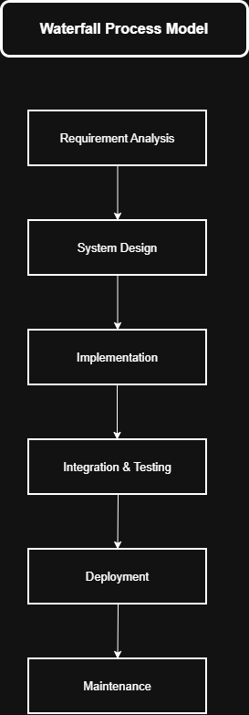

2. Spiral Component
The Spiral part focuses on risk handling, experimentation, and iterative improvement, particularly for the AI components of the system. Spiral cycles are used to:
- Improve symptom extraction accuracy
- Retrain/optimize ML models
- Test different NLP preprocessing techniques
- Evaluate prediction quality using sample data
- Incorporate user feedback loops
- Address ethical, accuracy, and usability risks
- Enhance explainability and safety features

Each spiral iteration includes the steps:
Identify risks → Plan → Develop prototype → Evaluate → Refine
This is essential because AI systems cannot be perfected in a single linear pass. They require experimentation, comparison, and incremental improvement.

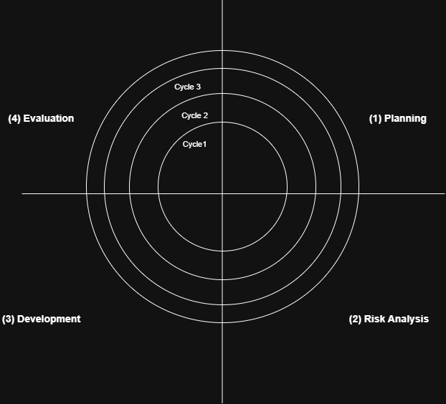

→1.7.1 Why VU Process Model Fits This Project
✔ The project has structured modules (login, chat, user management, admin controls) that suit Waterfall.
✔ The project also includes AI/ML components (symptom prediction, triage advice, explainability) that need iterative refinement.
✔ The hybrid model ensures both formal documentation and flexibility to improve the AI pipeline.
✔ It aligns exactly with what is taught in CS605 (SE-II) and what your supervisor expects.

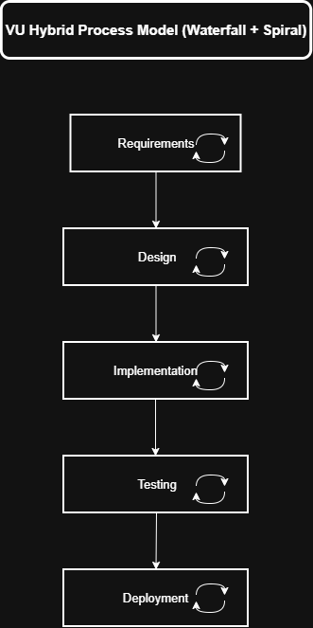

→Conclusion:
Therefore, the VU Process Model provides the perfect balance between planning and iteration, allowing the AI-powered health assistant to be developed with high accuracy, reliability, and maintainability while keeping risks under control.

1.7.2 Work Plan (Use MS Project to create Schedule/Work Plan)

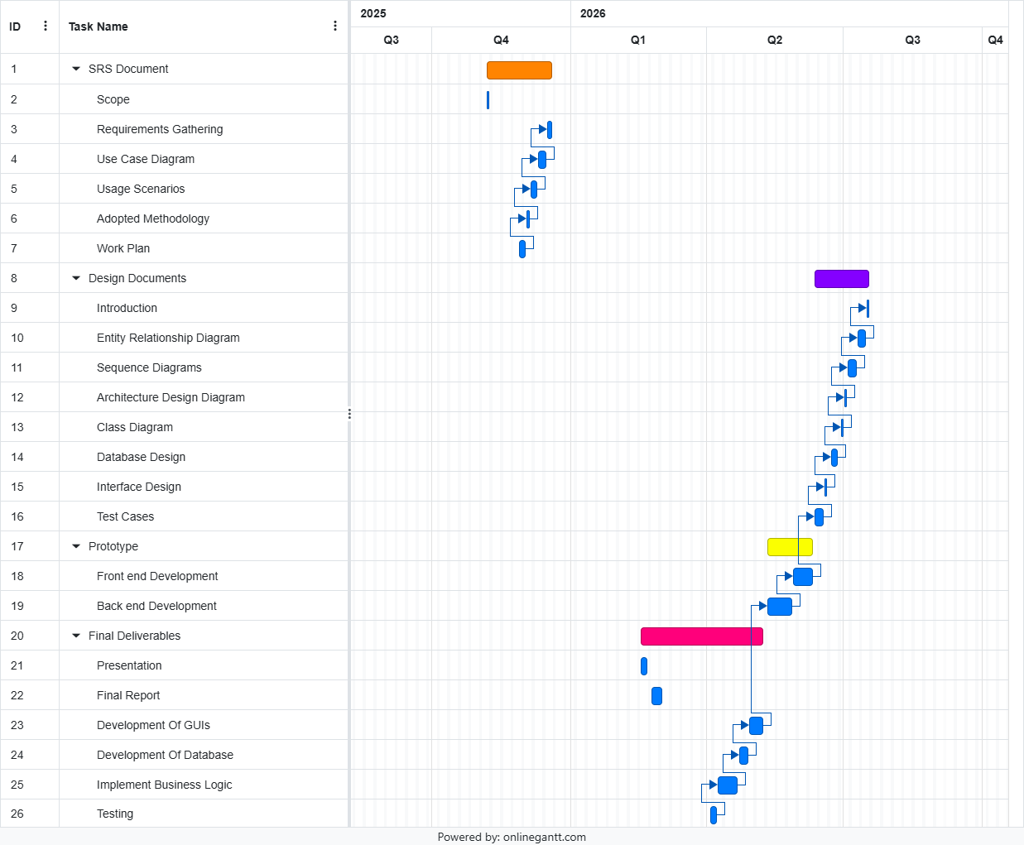

1.7.3 Submission Calendar:
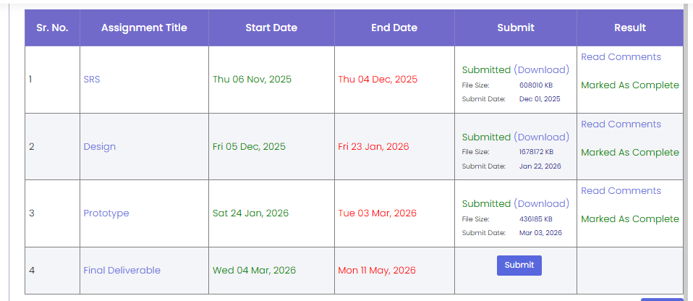

CHAPTER 2
Designing the Project

2.1 Introduction
This design document presents the detailed system design of the AI-Based Healthcare Chatbot System. The primary purpose of this document is to transform the approved Software Requirements Specification (SRS) into a well-structured technical design that guides system implementation, testing, and future maintenance.
The design document acts as a blueprint for developers and stakeholders by clearly defining the system architecture, data organization, component interactions, and user interface flow. It helps minimize ambiguity during development, improves implementation efficiency, and ensures alignment with the approved system requirements. Moreover, this document supports system scalability, maintainability, and effective collaboration throughout the software development lifecycle.
This document includes the following design artifacts:
- Entity Relationship Diagram (ERD):
Represents the conceptual data model of the system by identifying core entities, their attributes, and relationships, ensuring accurate data organization and integrity.
- Database Design Diagram:
Provides a logical view of how system data is structured and stored, mapping entities into database tables to support efficient data retrieval and persistence.
- Sequence Diagrams:
Illustrate the dynamic behavior of the system by showing the interaction flow between system components during key processes such as user authentication, symptom analysis, and AI prediction.
- Tiered Architecture Diagram:
Defines the overall system architecture by separating responsibilities into presentation, application logic, AI services, and data layers to ensure modularity and scalability.
- Class Diagram:
Describes the structural design of the system by identifying classes, their attributes, methods, and relationships, aligned with the system’s object-oriented design.
- User Interface Design:
Presents the visual flow of the system, demonstrating how users interact with the chatbot, view predictions, and understand AI-generated explanations through intuitive interfaces.
- Test Cases:
Outline the validation scenarios used to verify that system components function correctly and meet the specified design expectations.
Each design artifact is developed in alignment with the approved requirements to provide a complete, consistent, and implementation-ready view of the proposed system.

2.2 Entity Relationship Diagram (ERD)
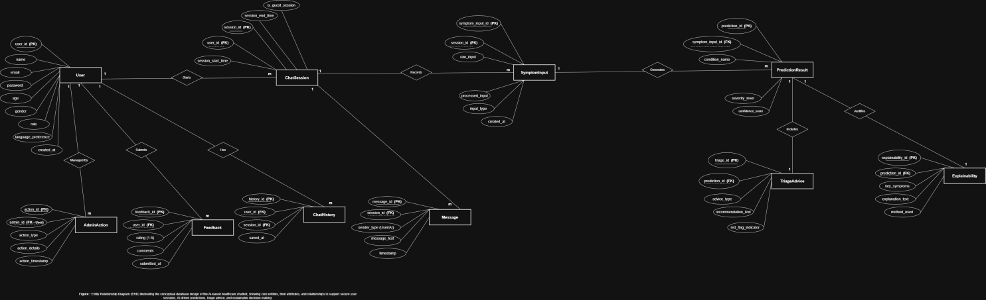
2.3 Sequence Diagrams
Sequence Diagram#01

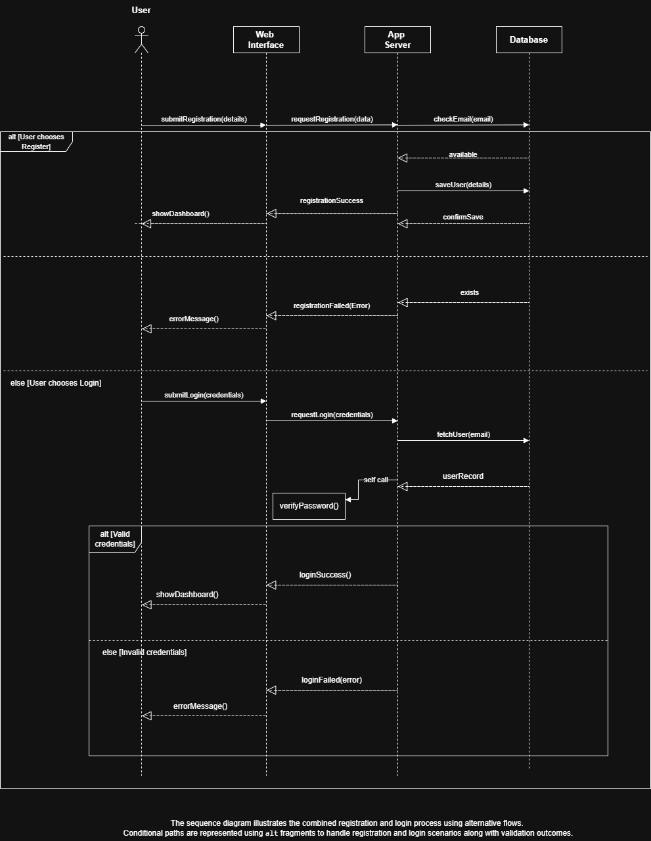
Sequence Diagram#02

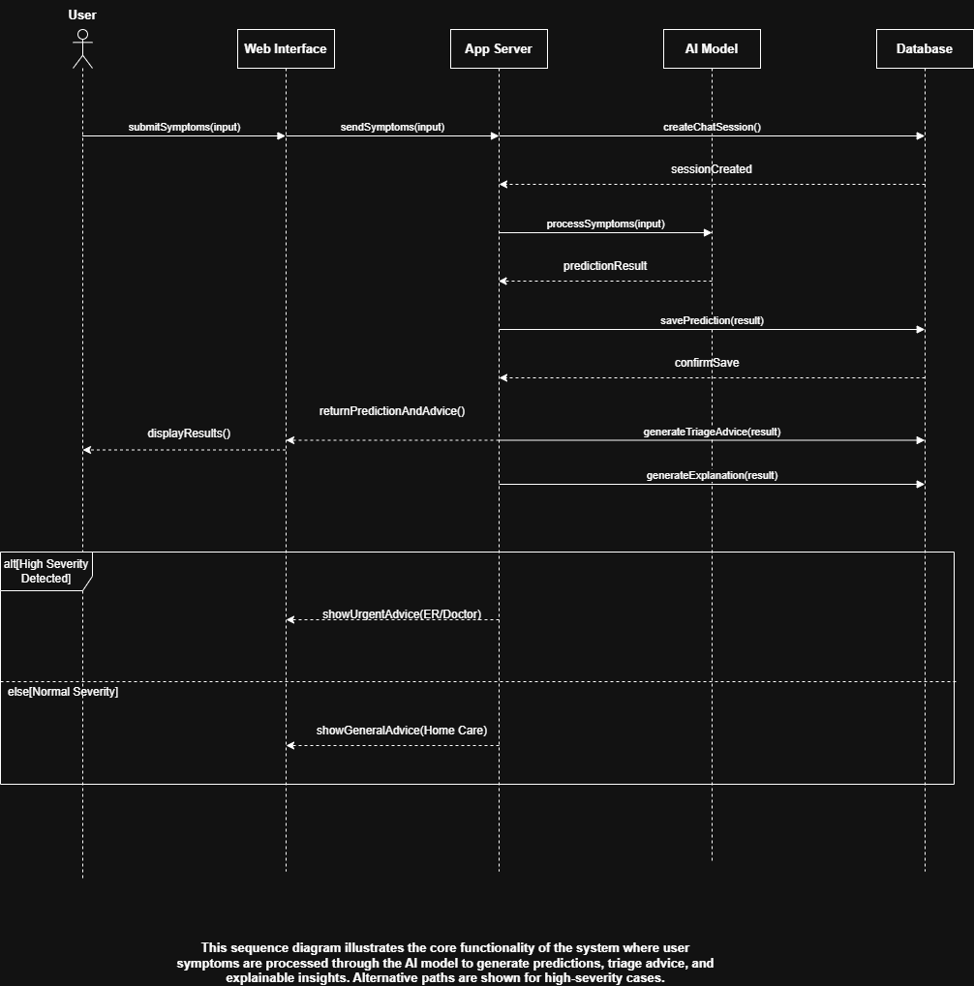
2.4 Architecture Design Diagram
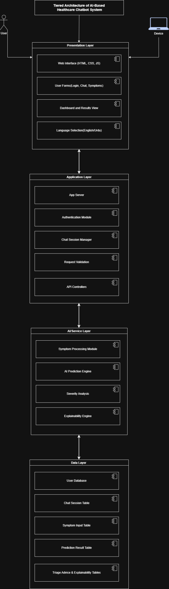
2.5 Class Diagram

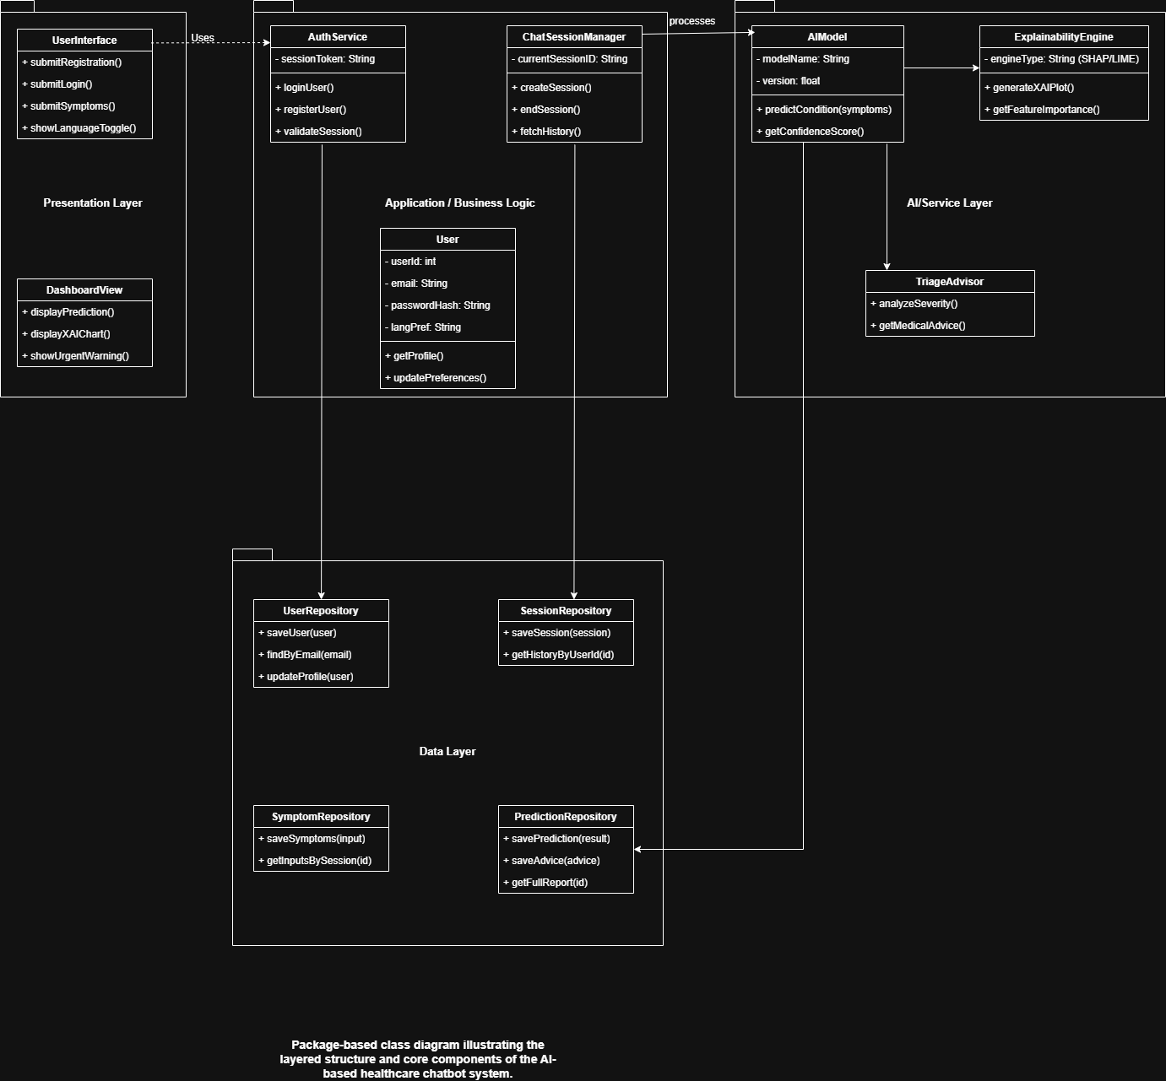

2.6 Database Design

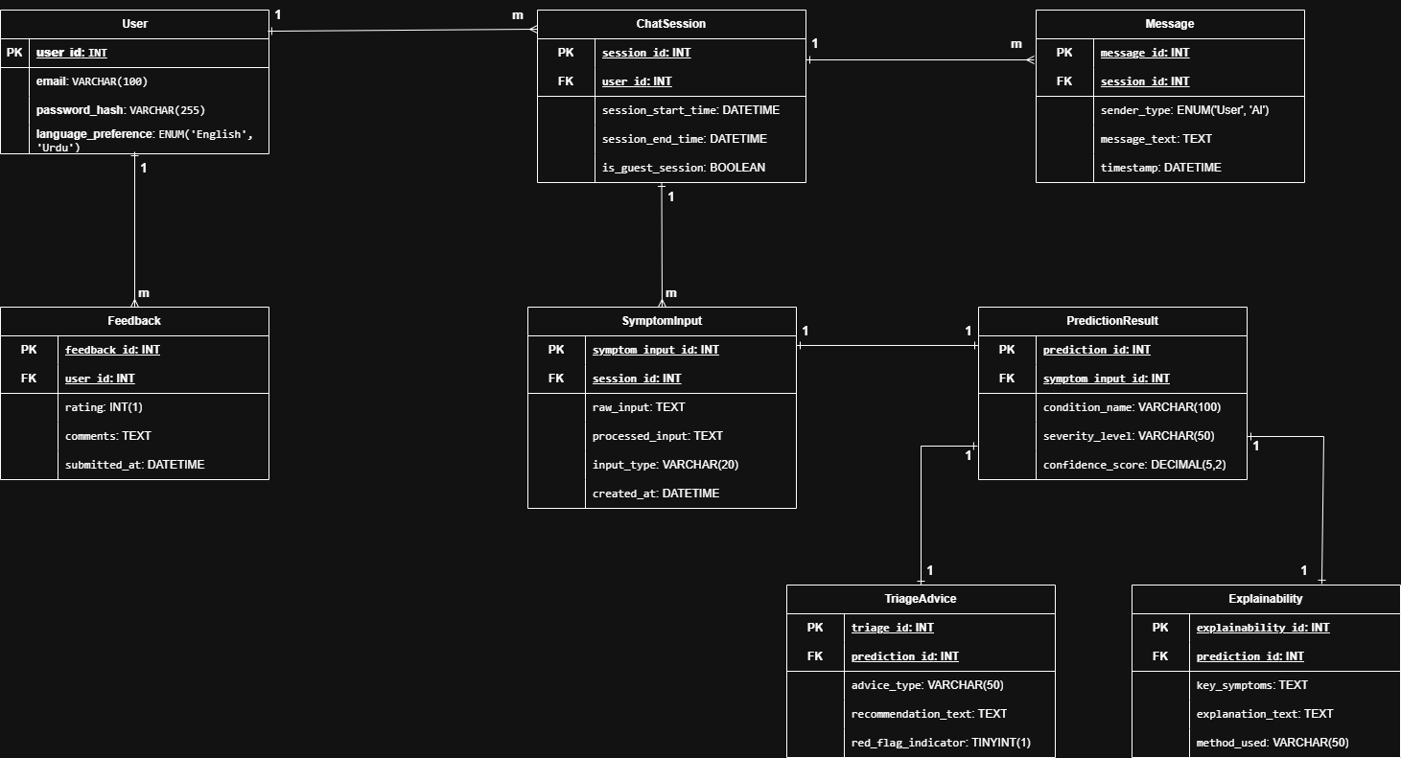

2.7 Interface Design

Interface#01: Login/Sign up
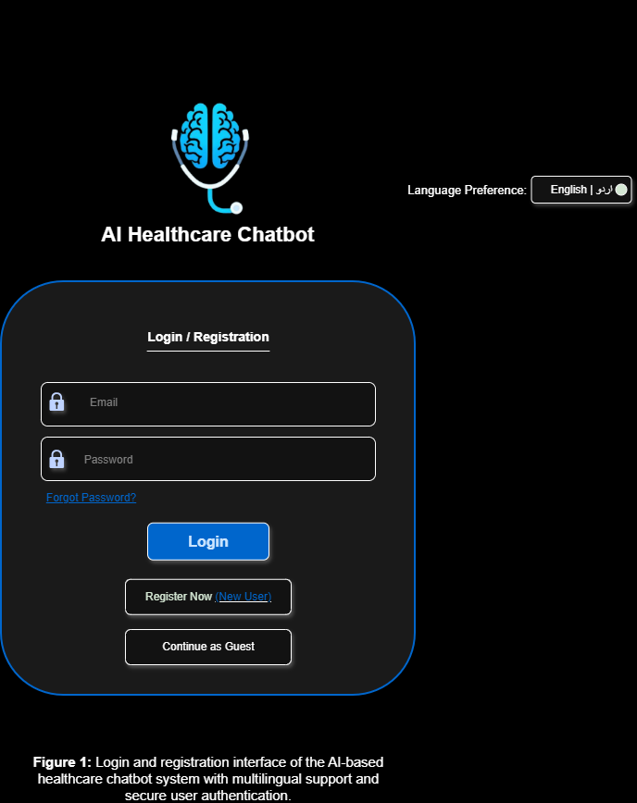

Interface#02: Main Chat/ Symptom Input Dashboard

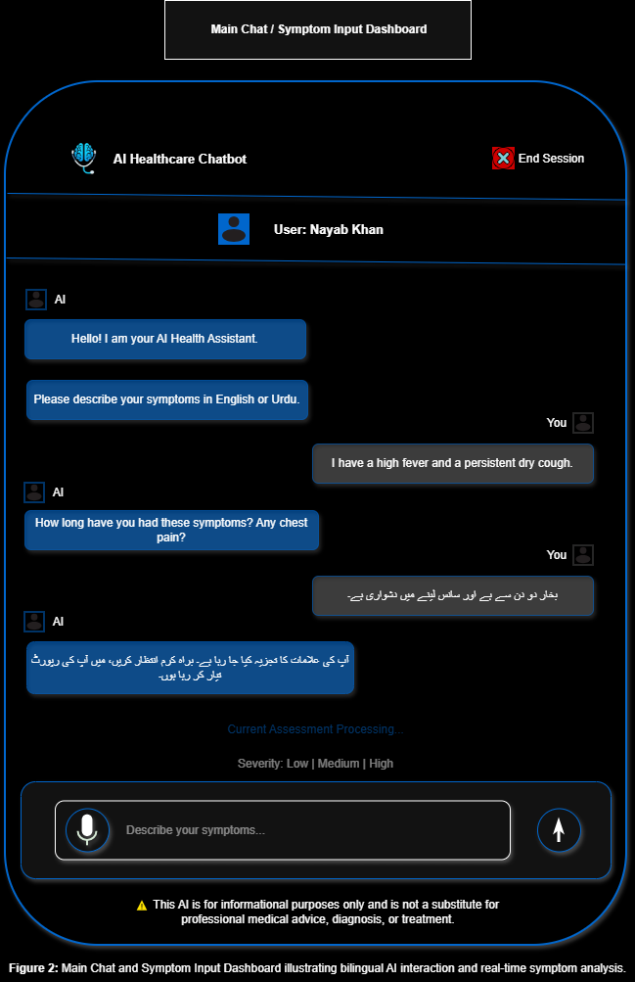
Interface#03: Assessment Results

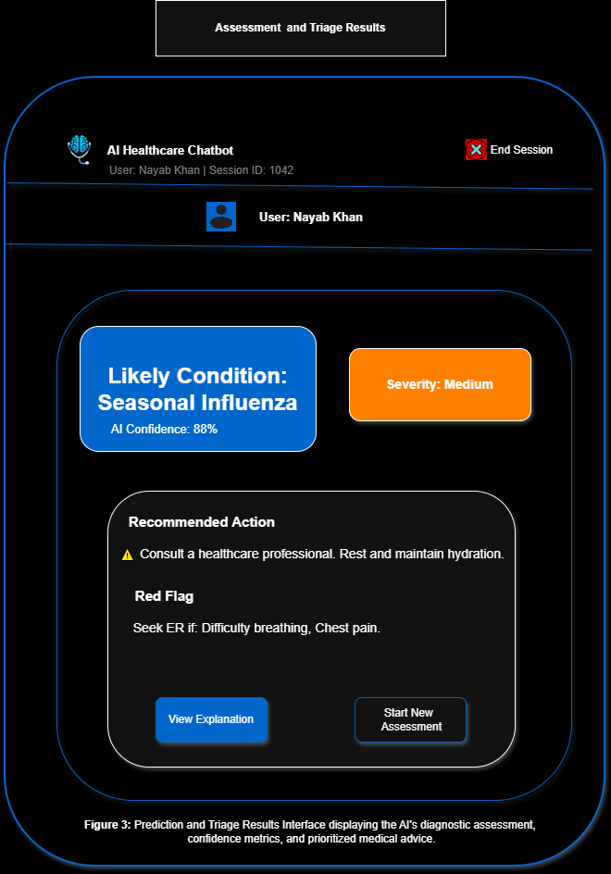
Interface#04: Explainability Dashboard

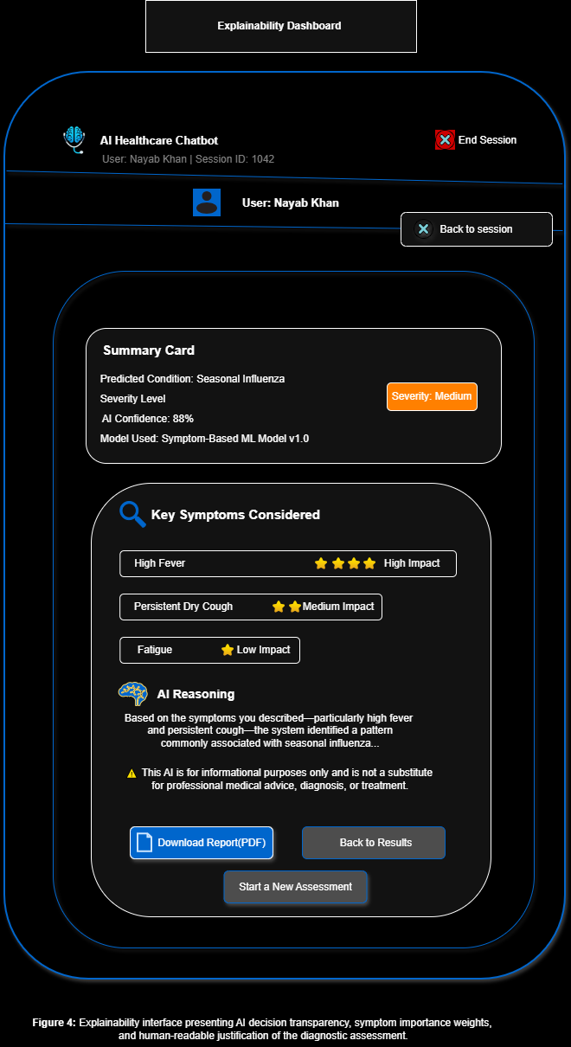

2.8 Test Cases

Test Case 1: User Login with Valid Credentials
Field | Description
Test Case ID | TC-01
Test Case Title | User Login with Valid Credentials
Precondition | User is registered in the system
Test Steps | 1. Enter valid email and password2. Click Login
Expected Result | User is authenticated and redirected to Chat Dashboard
Actual Result | As expected (Design Phase)
Status | Pass

Test Case 2: User Login with Invalid Credentials
Field | Description
Test Case ID | TC-02
Test Case Title | User Login with Invalid Credentials
Precondition | User exists
Test Steps | 1. Enter incorrect email/password2. Click Login
Expected Result | Error message displayed
Actual Result | As expected (Design Phase)
Status | Pass

Test Case 3: New User Registration
Field | Description
Test Case ID | TC-03
Test Case Title | New User Registration
Precondition | User not registered
Test Steps | 1. Click Register Now2. Enter valid details3. Submit form
Expected Result | Account created successfully
Actual Result | As expected (Design Phase)
Status | Pass

Test Case 4: Continue as Guest
Field | Description
Test Case ID | TC-04
Test Case Title | Guest User Access
Precondition | None
Test Steps | 1. Click Continue as Guest
Expected Result | Guest session created
Actual Result | As expected (Design Phase)
Status | Pass

Test Case 5: Symptom Input (Text)
Field | Description
Test Case ID | TC-05
Test Case Title | Submit Symptoms via Text
Precondition | Active chat session
Test Steps | 1. Type symptoms2. Click Send
Expected Result | Symptoms processed by AI
Actual Result | As expected (Design Phase)
Status | Pass

Test Case 6: Bilingual Input (Urdu)
Field | Description
Test Case ID | TC-06
Test Case Title | Urdu Language Symptom Input
Precondition | Language set to Urdu
Test Steps | 1. Enter symptoms in Urdu2. Submit
Expected Result | AI processes Urdu input correctly
Actual Result | As expected (Design Phase)
Status | Pass

Test Case 7: AI Condition Prediction
Field | Description
Test Case ID | TC-07
Test Case Title | Disease Prediction
Precondition | Symptoms submitted
Test Steps | 1. Submit symptoms
Expected Result | Likely condition displayed
Actual Result | As expected (Design Phase)
Status | Pass

Test Case 8: Severity Level Detection
Field | Description
Test Case ID | TC-08
Test Case Title | Severity Classification
Precondition | AI prediction completed
Test Steps | 1. View results screen
Expected Result | Severity shown as Low/Medium/High
Actual Result | As expected (Design Phase)
Status | Pass

Test Case 9: Triage Recommendation
Field | Description
Test Case ID | TC-09
Test Case Title | Medical Advice Generation
Precondition | Prediction available
Test Steps | 1. View Recommended Action
Expected Result | Appropriate medical advice displayed
Actual Result | As expected (Design Phase)
Status | Pass

Test Case 10: Red Flag Detection
Field | Description
Test Case ID | TC-10
Test Case Title | Emergency Warning Display
Precondition | High severity detected
Test Steps | 1. Submit critical symptoms
Expected Result | ER warning shown
Actual Result | As expected (Design Phase)
Status | Pass

Test Case 11: Explainability View
Field | Description
Test Case ID | TC-11
Test Case Title | AI Explanation Display
Precondition | Prediction completed
Test Steps | 1. Click View Explanation
Expected Result | Key symptoms & reasoning shown
Actual Result | As expected (Design Phase)
Status | Pass

Test Case 12: Download Report
Field | Description
Test Case ID | TC-12
Test Case Title | Download AI Assessment Report
Precondition | Explainability screen open
Test Steps | 1. Click Download PDF
Expected Result | Report downloaded successfully
Actual Result | As expected (Design Phase)
Status | Pass

Test Case 13: Start New Assessment
Field | Description
Test Case ID | TC-13
Test Case Title | New Chat Session
Precondition | Previous session active
Test Steps | 1. Click Start New Assessment
Expected Result | New session created
Actual Result | As expected (Design Phase)
Status | Pass

Test Case 14: End Session
Field | Description
Test Case ID | TC-14
Test Case Title | End User Session
Precondition | Active session
Test Steps | 1. Click End Session
Expected Result | Session terminated safely
Actual Result | As expected (Design Phase)
Status | Pass

CHAPTER 3
Development

3.1 Development Plan & Technology Stack
The AI-Powered Smart Health Assistant was developed using a full-stack web architecture, combining Python technologies on the backend with React and TypeScript on the frontend. The selected technologies were chosen based on project requirements, ease of integration, performance, scalability, and development efficiency.
The frontend was designed to provide an interactive and responsive user experience, while the backend handled API processing, database operations, authentication, and AI-based prediction tasks. Additional libraries and tools were integrated to support multilingual functionality, machine learning, data processing, visualization, and report generation.
The table below presents the technologies used in the project, the layer in which they were applied, and their respective purpose.
Layer | Technology | Purpose
Frontend | React 18 + TypeScript | Used to build the interactive single-page user interface of the system.
Frontend | Vite | Used as the development server and build tool for faster application performance during development.
Frontend | Tailwind CSS | Applied for responsive styling and efficient user interface design.
Frontend | shadcn/ui | Provided reusable and accessible interface components.
Frontend | Recharts | Used to display charts and visual analytics in the Explainability and Admin dashboards.
Frontend | Framer Motion | Added smooth transitions and animations to improve user experience.
Frontend | i18next | Enabled multilingual support for English and Urdu interfaces.
Frontend | React Router v6 | Managed navigation between pages within the application.
Frontend | Sonner | Displayed toast notifications for user actions and system feedback.
Backend | FastAPI | Served as the main Python framework for handling REST API requests and backend logic.
Backend | Uvicorn | Used to run the FastAPI server during development and testing.
Backend | Pydantic | Performed request validation and response schema management.
ML / AI | scikit-learn | Used for training and executing the machine learning classification model.
ML / AI | NLTK | Supported text preprocessing tasks such as tokenization and stop-word removal.
ML / AI | NumPy + Pandas | Assisted in data manipulation and preprocessing operations.
ML / AI | TF-IDF Vectorizer | Converted symptom descriptions into numerical features for machine learning analysis.
Database | SQLite (WAL Mode) | Used as the lightweight database for storing user and consultation data.
Reporting | ReportLab | Generated downloadable PDF health reports.
Security | SHA-256 (hashlib) | Used to securely hash passwords before storage.
Development Tools | VS Code | Main development environment used for writing and managing code.
Development Tools | Git + GitHub | Used for version control and project management.
Development Tools | Postman | Used to test API routes and verify backend responses during development.

3.2 Module-Level Implementation
The system was developed using a modular structure where each backend and frontend component was assigned a specific responsibility. This helped keep the application organized, easier to maintain, and simpler to test. The following sections briefly explain the purpose and implementation of each major module.

3.2.1 Backend: app.py Main API Server
The app.py file serves as the central controller of the backend application. Built using FastAPI, it manages all API routes and coordinates communication between different system modules.
Key responsibilities of this module include:
- Application startup: The init_db() function runs automatically to create required database tables if they do not already exist.
- API route management: Handles all major endpoints including prediction, authentication, feedback, PDF generation, history retrieval, and admin operations.
- Prediction orchestration: The /predict endpoint processes symptom input through:
  - Validation
  - NLP preprocessing
  - Feature extraction
  - ML prediction
  - Triage generation
  - Personalization
  - Explainability
- Database integration: Saves consultation results after successful analysis.
- Triage mapping: Converts backend triage values (Low, Medium, High) into frontend-friendly labels (self-care, visit-gp, urgent-care) for consistent display.
- Cross-origin support: CORS settings allow smooth communication between frontend and backend during development.

Module3.2.2 Backend: src/preprocessing.py NLP Cleaning Module
This module prepares user symptom text before it is analyzed by the machine learning model. Since user input can vary in wording and quality, preprocessing helps improve consistency and prediction accuracy.
The module performs the following tasks:
- Text cleaning: The clean_text function:
  - Removes punctuation
  - Converts text to lowercase
  - Eliminates unnecessary stop words
  - Corrects common spelling mistakes
- Medical term normalization: Converts informal phrases into standardized medical terms. Examples include:
  - tummy pain → abdominal pain
  - feaver → fever
- Input validation: The validate_medical_text function acts as a safety filter by detecting:
  - Extremely short input
  - Non-medical text
  - Personally identifiable information (PII)
  - Unsafe or harmful keywords
- Error handling: Returns informative messages when input is invalid instead of forwarding poor-quality data to the prediction model.

3.2.3 Backend: src/classifier.py and src/feature_extraction.py ML Pipeline
These modules handle the core machine learning process responsible for predicting possible health conditions.
The implementation includes:
- Feature extraction: The TF-IDF vectorizer converts cleaned symptom text into numerical feature vectors.
- Pre-trained model loading: The vectorizer and classifier are loaded once during server startup to avoid repeated loading delays.
- Probability-based prediction: The classifier uses predict_proba() to calculate confidence scores for all possible conditions.
- Top-three condition selection: The predict_top_k function:
  - Selects the three most likely conditions
  - Ranks them by confidence level
  - Returns prediction details in structured form
- Result formatting: Each prediction contains:
  - Condition name
  - Confidence percentage
  - Brief condition description
- Pipeline integration: Prediction results are forwarded to the triage and explainability modules for further processing.

3.2.4 Backend: src/triage.py Triage and Personalization Module
This module transforms prediction results into practical health guidance to help users better understand their situation.
Main functions of this module include:
- Triage generation: The generate_triage function assigns one of three urgency levels:
  - Low
  - Medium
  - High
- Specialist recommendation: Suggests an appropriate medical specialist based on the predicted condition.
- Personalized guidance: The generate_personalized_guidance function adjusts results using patient details such as:
  - Age
  - Gender
  - Severity level
  - Pregnancy status
  - Chronic illness history
- Rule-based recommendations: Examples include:
  - Patients below 18 years may receive a Pediatrician recommendation.
  - Pregnancy-related cases may trigger warning messages.
  - High severity input can increase urgency level.
- Self-care suggestions: Generates condition-specific health advice rather than generic recommendations.

3.2.5 Backend: src/database.py Database Access Layer
This module manages all database-related operations using SQLite.
Its key responsibilities include:
- Database initialization: The init_db() function creates required tables if they do not already exist.
- Connection management: The get_connection() function:
  - Enables foreign key support
  - Activates WAL mode for safer concurrent database access
- Password security: User passwords are protected using SHA-256 hashing before storage.
- Consultation storage: Saves prediction results, triage levels, and consultation history.
- Feedback handling: Stores user ratings and optional comments for completed consultations.
- Admin support functions: Additional functions added in the final version include:
  - get_analytics_summary() for dashboard statistics
  - get_all_users_admin() for user management
  - update_user_role() for modifying user roles

Module 3.2.6 Backend: src/explainability.py Explainability Module
This module was included to make prediction results more transparent and understandable for users.
The module performs the following tasks:
- Feature importance extraction: Identifies symptom-related words that influenced the prediction outcome.
- Model analysis: Uses the trained classifier and TF-IDF vectorizer to determine important features.
- Keyword ranking: The get_top_features function selects the most influential symptom terms.
- Simplified output: Instead of displaying technical values, the system only returns meaningful symptom keywords.
- Frontend integration: The extracted words are displayed under the key_symptoms section to help users understand why a specific prediction was generated.

3.2.7 Frontend: SymptomChecker.tsx Chat Interface
This component acts as the main interaction screen where users communicate with the AI assistant.
Its implementation includes:
- Chat management: Handles user messages and AI-generated responses.
- Voice input support: Integrates the Web Speech API for optional symptom input through voice.
- Patient metadata panel: Allows users to enter optional information such as age, severity level, pregnancy status, and chronic illness history.
- Prediction handling: Sends symptom data to the backend using the prediction API.
- Inline result display: Shows prediction results directly inside the chat through the ResultCard component.
- Session storage: Saves prediction results and consultation IDs to sessionStorage for later access.

3.2.8 Frontend: Explainability.tsx Full Analysis Page

This module is responsible for transforming the "black box" nature of machine learning into a transparent experience for the user. It ensures that every health prediction is backed by clear, symptomatic reasoning.

The module performs the following tasks:

SHAP-Based Attribution: Utilizes the SHAP (SHapley Additive exPlanations) LinearExplainer to calculate exact Shapley values, determining the mathematical contribution of each symptom to the final prediction.

Feature-Model Analysis: Directly analyzes the TF-IDF vectorizer's feature names and the Logistic Regression model’s decision boundary to pinpoint influential tokens.

Influential Keyword Ranking: The get_influencing_symptoms function (supported by get_top_features) identifies and ranks the top symptom terms based on their impact scores.

Robust Fallback Mechanism: Includes a coefficient-based scoring backup. If the SHAP library is unavailable, the module automatically switches to analyzing model coefficients to ensure the user always receives an explanation.

UI Transparency: Cleaned symptom keywords are sent to the React frontend, populating the "Key Symptoms" panel to explain the "why" behind the AI's assessment.

3.2.9 Frontend: FeedbackWidget.tsx Feedback Component
This component was added in the final version to improve user engagement and collect system feedback.
Its main functions include:
- Star rating system: Allows users to rate responses from 1 to 5 stars.
- Optional comments: Users may leave additional feedback through a text field.
- API integration: Sends feedback to the backend using the /feedback endpoint.
- Consultation linking: Uses stored consultation IDs to associate ratings with the correct analysis session.
- Duplicate handling: Prevents repeated feedback submission for the same consultation.

3.2.10 Frontend: AdminDashboard.tsx Admin Panel
The admin dashboard was developed to support system monitoring and management.
Its implementation includes:
- Secure authentication: Admin login is handled through a password-protected endpoint.
- Analytics dashboard: Displays:
  - Total users
  - Total consultations
  - Average ratings
  - Triage distribution
- Data visualization: Uses charts for:
  - Top conditions
  - Specialist demand
  - Daily activity trends
- User management: Allows role updates directly through the dashboard.
- Backend integration: Retrieves analytics and user data from protected admin endpoints.

3.3 API Endpoints Reference
The backend of the AI-Powered Smart Health Assistant was implemented using multiple API endpoints to support prediction, authentication, consultation history, feedback collection, PDF generation, and administrative operations. Table 3.1 presents the API endpoints included in the final system implementation along with their authentication requirements and primary functions.
Method | Endpoint | Authentication | Description
GET | / | None | Health check endpoint that returns API version and group information
POST | /predict | None | Accepts symptoms and optional patient details, executes the complete ML pipeline, and returns prediction results, triage level, and explainability output
GET | /history | user_id | Retrieves the latest 10 consultations for a registered user
POST | /auth/login | None | Validates user credentials and returns profile information without exposing password data
POST | /auth/register | None | Creates a new user account and returns profile information upon successful registration
POST | /feedback | None | Saves user rating and optional comments for a consultation
POST | /generate-pdf | None | Generates and returns a downloadable PDF health report from the analysis result
POST | /admin/login | None | Validates admin credentials and returns an authentication token
GET | /admin/analytics | admin_key | Retrieves aggregated analytics data for the admin dashboard
GET | /admin/users | admin_key | Returns anonymized user records for administrative review
POST | /admin/users/{id}/role | admin_key | Updates the role of a selected user

3.4 Test Cases & Results

To validate the working prototype, selected high-priority test cases were executed and verified through actual system output screenshots. The following figures show the successful execution of core system functionalities.

TC-01: User Login with Valid Credentials
Figure 3.1: Successful Login Screen
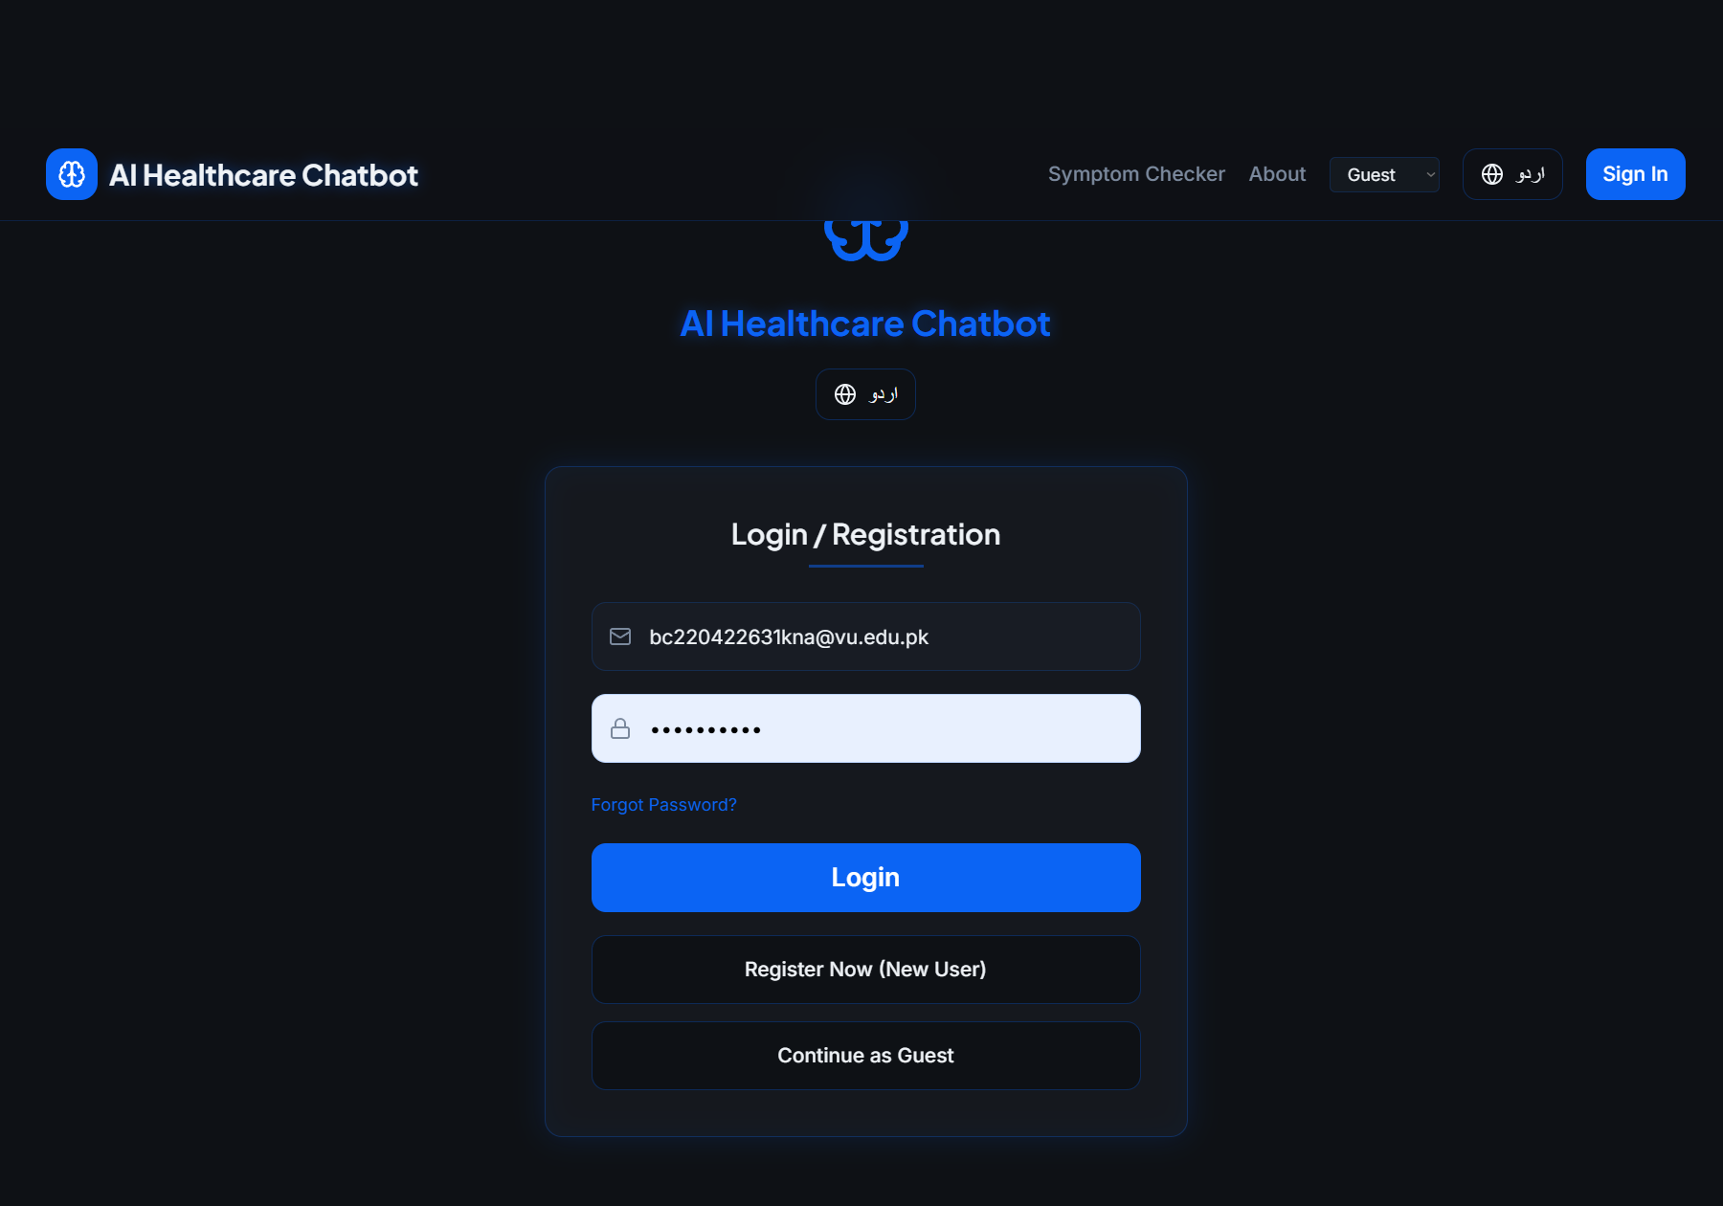

TC-05: Symptom Input and Prediction
Figure 3.2: AI Prediction Result Screen
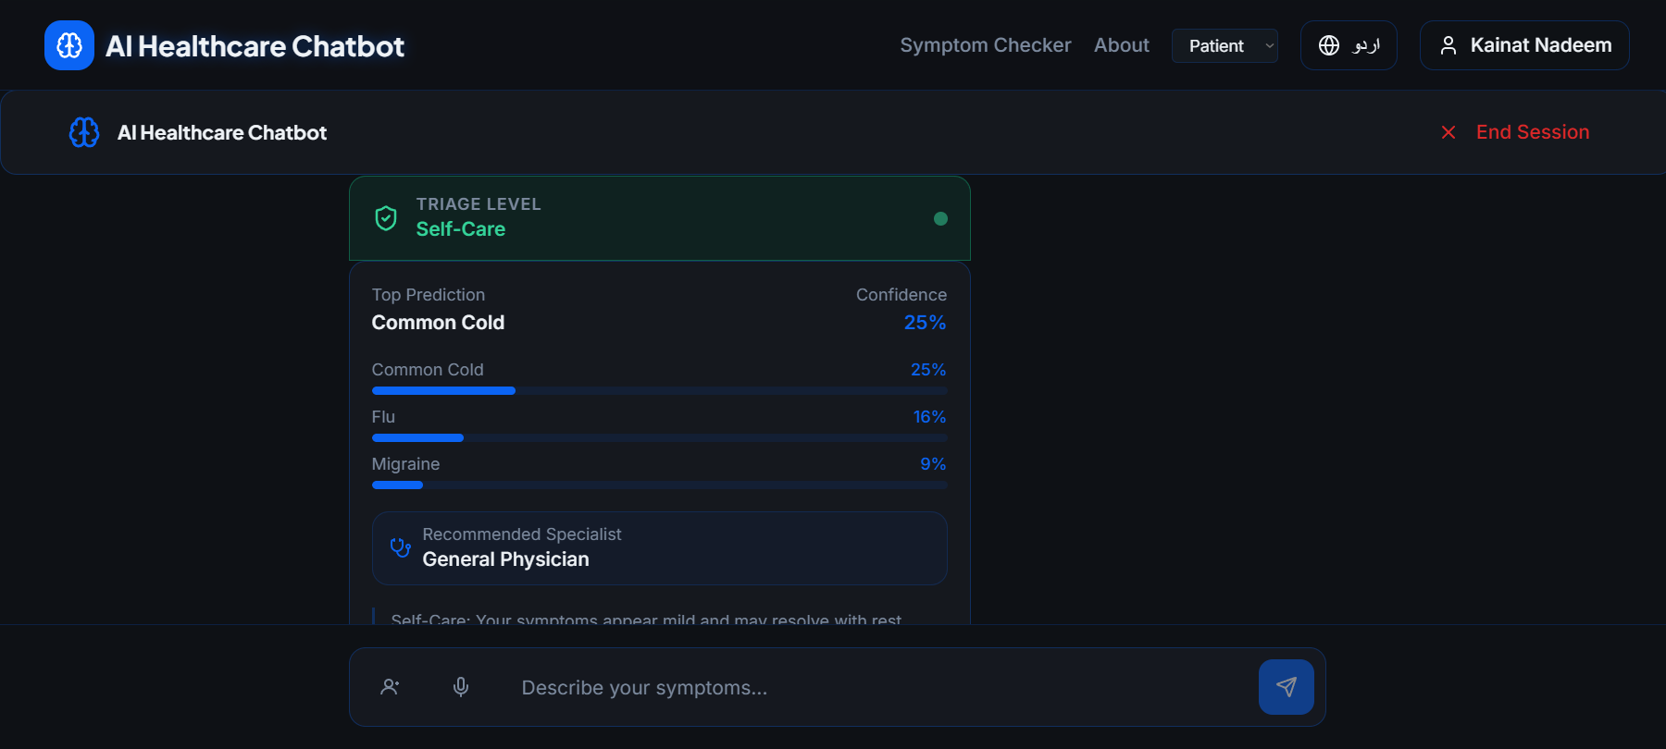

TC-06: Urdu Language Symptom Input
Figure 3.3: Urdu Input Testing
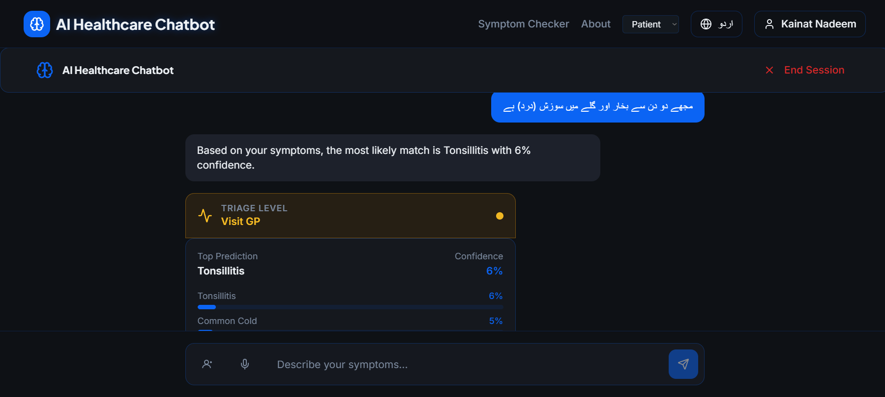

TC-11: Explainability View
Figure 3.4: Explainability Page Result
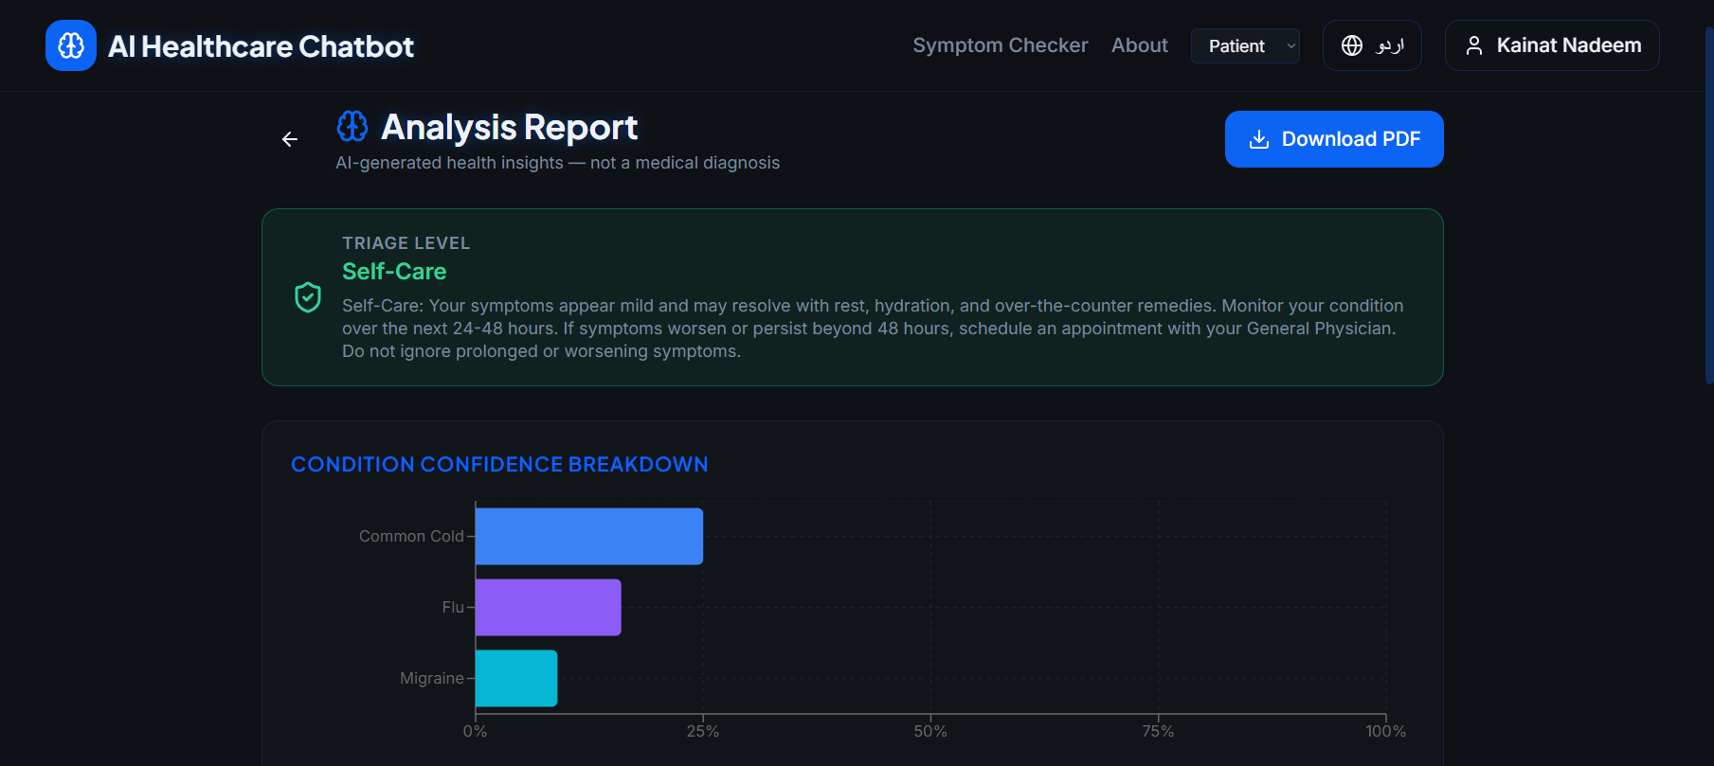

TC-12: PDF Report Download
Figure 3.5: PDF Export Result
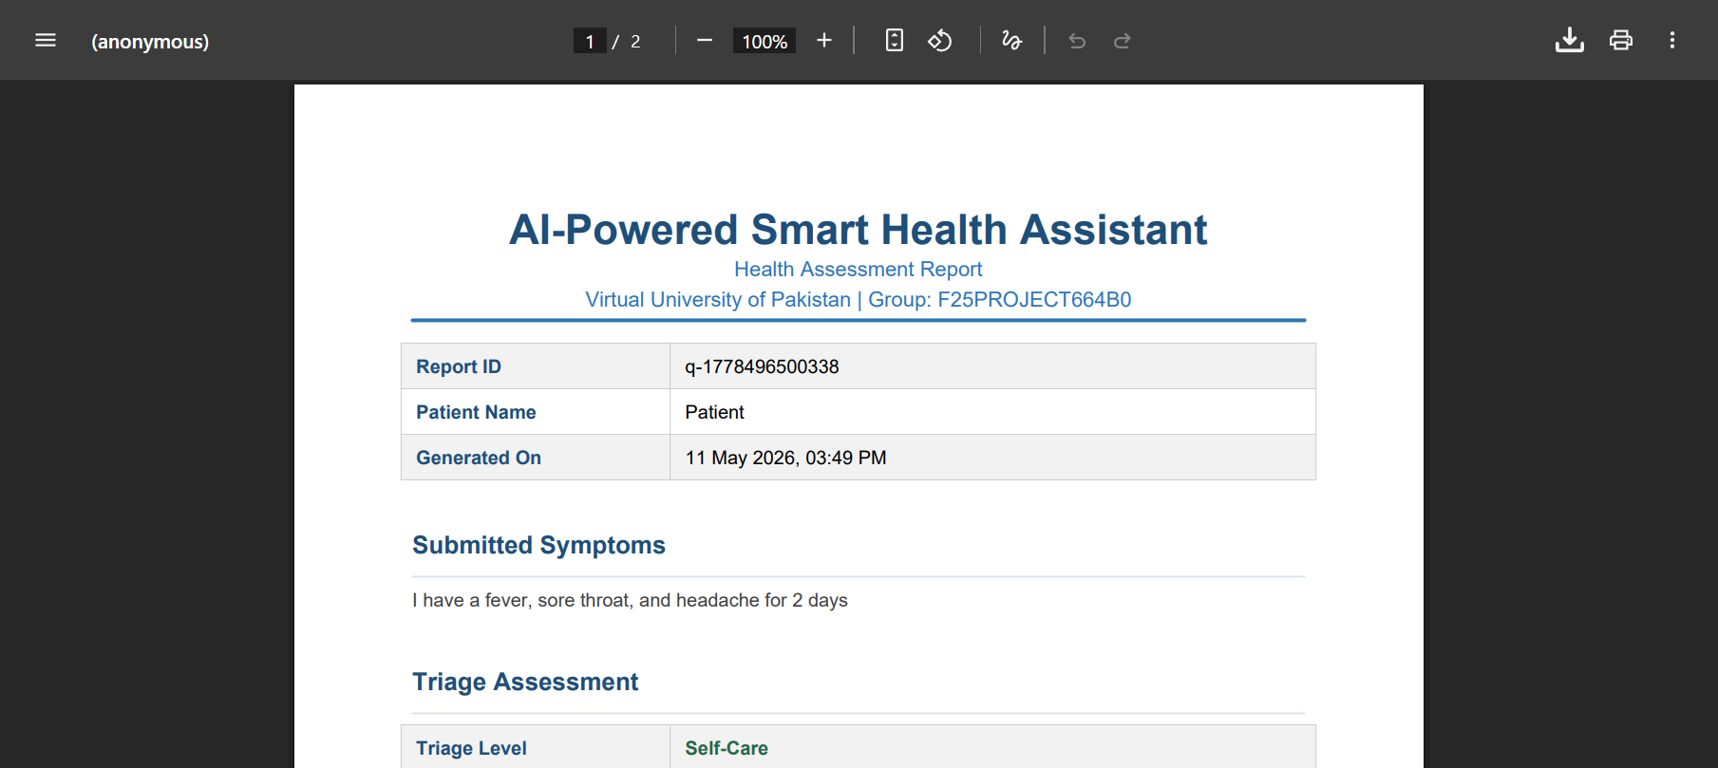

TC-15: Admin Analytics Dashboard
Figure 3.6: Admin Dashboard Screen
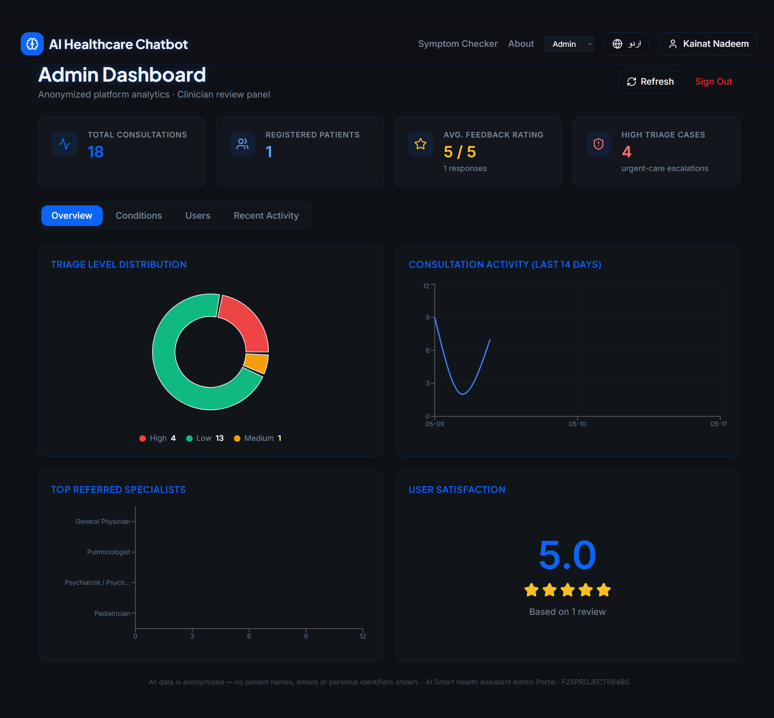

3.5 Challenges & Solutions
During the development phase, several technical and implementation challenges were encountered. Each challenge provided useful learning opportunities and helped improve the overall system.
Challenge | Solution
Triage format mismatch between backend and frontend | The database required Low/Medium/High, while the frontend expected self-care/visit-gp/urgent-care. This was solved by creating a mapping dictionary in app.py to convert values before returning the response.
PDF generation for guest users failed | The initial prototype relied on database lookup, which failed for guest sessions. The issue was solved by sending the complete result payload directly from the frontend to the PDF endpoint.
Server startup ImportError | Some admin functions were referenced but not implemented, causing the server to fail during startup. Missing functions were fully implemented in database.py.
Feedback submission missing consultId | The feedback component required a consultation ID that was not being stored. This was resolved by saving the returned query ID in sessionStorage after prediction.
Voice input compatibility issues | Voice input worked best in Chrome but failed silently in some browsers. A browser compatibility check and clear warning message were added.
SQLite concurrent write issues | Multiple requests sometimes caused database locking errors. WAL mode was enabled to improve concurrent read and write operations.
Urdu text misclassification | Since the ML model was trained mainly on English text, Urdu predictions were sometimes inaccurate. This limitation was documented clearly and future Urdu support was planned.

3.6 Future Enhancements
While the current version of the AI-Powered Smart Health Assistant successfully meets its primary functional goals, the following upgrades are proposed to further evolve the platform’s capabilities and user reach:
- Transition to Stateless Authentication: The current architecture utilizes robust role-based access control (RBAC). Future iterations will shift toward JSON Web Tokens (JWT) to facilitate stateless authentication, improving the system’s ability to scale and integrate with third-party microservices.
- Geospatial Healthcare Mapping: To close the loop between analysis and action, we plan to integrate Google Maps and healthcare directory APIs. This would allow the system to automatically suggest and book appointments at the nearest specialized clinics based on the user's identified condition.
- Rich Graphical Interpretability: Currently, the system provides high-accuracy text-based explanations via SHAP. Future development will focus on rendering interactive force plots and summary graphs using Plotly.js, making the AI’s "thought process" even more accessible to non-technical users.
- Cross-Platform Mobile Presence: To improve accessibility, the assistant will be ported to React Native or Flutter. This will enable native mobile features such as push notifications for follow-up care and offline access to previous health consultations.
- Self-Evolving AI Pipeline: We aim to implement an automated MLOps pipeline that monitors the system’s feedback loop. Once a significant volume of verified user data is collected, the model would automatically retrain itself to improve prediction precision over time.
- Global Healthcare Interoperability: Future versions will aim for HL7 FHIR compliance. This would allow the AI-generated assessment reports to be digitally transmitted directly into official hospital Electronic Health Record (EHR) systems, streamlining the patient-doctor intake process.
- Bilingual Vocal Feedback: To assist users with visual impairments or low literacy, we plan to incorporate Text-to-Speech (TTS) engines in both English and Urdu. This will allow the system to audibly communicate triage advice and specialist recommendations.
REFERENCES

[1] Virtual University of Pakistan. (2025). CS619 Final Year Project Guidelines. Department of Computer Sciences.

[2] Virtual University of Pakistan. (2025). CS504 Software Engineering Helping Material. Department of Computer Sciences.

[3] Virtual University of Pakistan. (2025). CS403 Database Management Systems Helping Material. Department of Computer Sciences.

[4] Virtual University of Pakistan. (2025). Software Requirements Specification (SRS) and Design Documentation Guidelines. Software Projects & Research Section.

[5] FastAPI Documentation. (2024). FastAPI: Modern Python Web Framework. https://fastapi.tiangolo.com

[6] scikit-learn Developers. (2024). scikit-learn: Machine Learning in Python. https://scikit-learn.org

[7] React Documentation. (2024). React: A JavaScript Library for Building User Interfaces. https://react.dev

[8] NLTK Project. (2024). Natural Language Toolkit Documentation. https://www.nltk.org

[9] Lundberg, S. M., & Lee, S. I. (2017). A Unified Approach to Interpreting Model Predictions. Advances in Neural Information Processing Systems, 30.

[10] ReportLab Inc. (2024). ReportLab PDF Library. https://www.reportlab.com

[11] SQLite Documentation. (2024). SQLite Home Page. https://www.sqlite.org

[12] Vite Documentation. (2024). Vite: Next Generation Frontend Tooling. https://vitejs.dev

[13] Tailwind CSS. (2024). Utility-First CSS Framework. https://tailwindcss.com

[14] i18next. (2024). Internationalization Framework for JavaScript. https://www.i18next.com

APPENDIX

Chapter 1:
- Gathering & Analyzing Information
  - Includes project introduction
  - Scope
  - Requirements
  - Use cases
  - Methodology

Chapter 2:
- Designing the Project
  - Includes architecture
  - UML diagrams
  - Database design
  - Interface designs.

Chapter 3:
- Development
  - Includes technology stack
  - Implementation details
  - Testing, challenges
  - Future enhancements.

